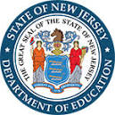

New Jersey Department of Education
2020-2021

Flinn Scientific
Alignment to New Jersey’s
Restart & Recovery Plan

Executive Summary 4
Ideal Partner for New Jersey Institutions 5
Trusted Name in School Safety 5
Partner in Science and STEAM Education 5
Customer -Centric and Responsive 5
Standards-Aligned Support Products – NGSS 5
Standards-Aligned Support Products – NJSLS 6
Alignment to New Jersey Subject Areas 7
Conditions for Learning 7
Leadership and Planning 7
Policy and Funding 8
Continuity of Learning 10
Professional Learning Solutions 12
Covid-19 Guidance to Re-entry to Schools 12
Laboratory Safety in a Covid-19 Environment 12
Elementary Science and STEM Safety K-8 12
Prep Room COVID-19 Concerns 12
Chemventory™ & Science Safety Courses for Teachers™ 12
Blended Learning Solutions 14
WhiteBox Learning™ 14
FlinnSTEM® 14
Science2Go 15
360 Science® 15
FlinnPrep® 16
Digital Dissection 16
Personal Protective Equipment 17
Surgical Face Masks 17
Woodbridge INOAC Filter Pore Foam Masks 17
Nitrile Gloves 18
Universal Sanitizer 18
Face Shields 18
IR Thermometers 18
Chemical Splash Safety Goggles and Sanitizer 19
Signage 19
Acrylic Barriers 19
Laboratory Supplies & Science Resources 20
Equipment, Glassware, Chemicals 20
Chemventory™ 20
SciMatCo Storage Cabinets 21
U-Design™ – Science & STEM Labs – Online Planner 21
Customer Experience 22
Project Leads 22
Communications Plan 22
Customer Care Team Lead 23
Equipment and Warranty Service Contracts 23
Customized Packaging by Classroom / Instructor 23
White Glove Service Option 23
Science Essential Purchase Guide™ - Ordering made Easy 23
Flinn Overview 24
Our Mission 25
Our Philosophy 25
Our Core Values 25

Executive Summary

The COVID-19 pandemic impacted every aspect of our lives. As we look to the future and plan for students to return to schools in-person this fall, we must recognize and prepare for the ways the virus and necessary public health response has changed and will change the way students learn. This Restart and Recovery Plan provides educators and administrators with the information needed to ensure that our schools reopen safely and are prepared to accommodate students’ unique needs during this unprecedented time.

The Plan presents guidance related to four key subject areas:

1. Conditions for Learning
2. Leadership and Planning
3. Policy and Funding
4. Continuity of Learning

Throughout the document, the term “anticipated minimum standards” is used to refer to items that school districts should incorporate into their reopening plans as definite components related to health, safety, and operations. The term “considerations” is used to refer to components that districts and schools should incorporate into their thinking about reopening, but do not represent necessary components of plans. The New Jersey plan document can be found here: NJDOE The Road Back

Flinn Scientific understands the stress and time constraints everyone is under to determine and implement their back to school plans. This document is designed to offer return-to-school safety resources in the form of professional learning, personal protective equipment ideas, as well as curriculum support for science and STEM solutions perfect for instruction capable of supporting educators in a flipped environment and students with multi-modalities of learning.

Ideal Partner for New Jersey Institutions
Flinn Scientific (Flinn) was created from a desire to serve science educators. The company has grown to become the trusted source for a safe return to schools and the leader in remote science and STEAM education. Our brand promise speaks for itself; Premium Quality, Exceptional Service, and Deep Scientific Expertise, Guaranteed!

Trusted Name in School Safety
Flinn Scientific supports science educators in opening young minds to the challenges and joys of scientific discovery. The leader in science lab supplies and safety, we provide learning systems and professional learning that incorporate differentiated digital experiences with hands-on learning to bring out the inner scientist in every student. America’s science teachers rely on Flinn’s leadership, reputation, and commitment to bring the best of science education solutions for their students.

Partner in Science and STEAM Education
Flinn Scientific creates programs and experiences that teach your students to think critically and evaluate information - building a passion for exploration and scientific inquiry. Additionally, programs: 1.) are highly adaptable to suit students of various learning modalities, incorporating inquiry-based principles, 2.) take an applied approach that is grounded in the real-world, teaching skills in a way they will be used in the workforce and real life, 3.) establish a strong education and laboratory infrastructure focused on safety and 4.) ensure science and STEAM is well integrated with the education system as a critical component for self-discovery.

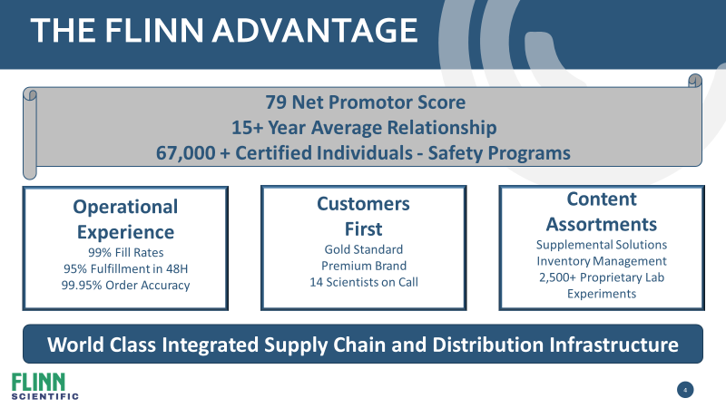
Customer -Centric and Responsive
- Strong brand equity and a legacy of understanding and fulfilling school districts and their educator’s needs.
- Past, present, and future product roadmaps emphasize the importance of experiencing science in a blended learning environment.
- Flinn’s promise is: Premium Quality, Exceptional Service, and Deep Scientific Expertise, Guaranteed!

Standards-Aligned Support Products – NGSS
The three-dimensional approach of the Next Generation Science Standards (NGSS) is transforming the experience of science for your students and you! It is a journey we are committed to taking with you.
Gain teaching inspiration from a growing repository of articles written by scientists in the field, videos highlighting the 3-dimensional teaching journey, and webinars and resources provided by your teaching colleagues in the field. PLUS search our 1,000+ NGSS-aligned labs, kits, and digital solutions. Flinn has everything you need to navigate a successful NGSS journey! Flinn and NGSS

Standards-Aligned Support Products – NJSLS
The New Jersey Student Learning Standards include Preschool Teaching and Learning Standards, as well as nine K-12 standards for the following content areas:
21st Century Life and Careers
Comprehensive Health and Physical Education
English Language Arts
Mathematics
Science
Social Studies
Technology
Visual and Performing Arts
World Languages
Flinn Scientific science and STEM-related content and digital solutions for a traditional in-class, remote or hybrid model aligns with the NJSLS 21st Century Life and Careers, Science, and Technology clusters. Get a start on your curriculum alignment while meeting the COVID-19 response to restarting school safely:
- Science (September 2021) - NJSLS Science Standards Document
- Technology and Career Readiness (September 2021) - NJSLS Technology and Career Readiness Documents
- Computer Science and Design Thinking (September 2022) - NJSLS Computer Science and Design Thinking Document

Alignment to New Jersey Subject Areas

Conditions for Learning
Conditions for learning must address not only students’ and educators’ basic physical safety needs, but also the social and emotional and environmental factors that can impact educators’ capacity to teach and students’ capacity to learn.

At a minimum, school districts must adopt a policy for screening students and employees for symptoms of COVID-19 and history of exposure and must strive for social distancing within the classroom and on school buses. If schools are not able to maintain this physical distance, additional modifications should be in place, including physical barriers between desks and turning desks to face the same direction. Each school district must also adopt cleaning and disinfecting procedures.

School staff and visitors are required to wear face coverings unless doing so would inhibit the individual’s health or the individual is under two years of age. Students are strongly encouraged to wear face coverings and are required to do so when social distancing cannot be maintained unless doing so would inhibit the student’s health. It is also necessary to acknowledge that enforcing the use of face coverings may be impractical for young children or individuals with disabilities.

Flinn Scientific aligns to New Jersey’s Conditions for Learning:
- Flinn’s Professional Learning
- Flinn’s Personal Protective Equipment

Leadership and Planning
Adjusting the school environment to ensure the health and safety of students and staff will require a great deal of planning. School districts should create Restart Committees to coordinate the overall reopening plan. These Committees should include district- and school-level administrators, school board members or charter trustees, local education association representatives, educators, parents, and students.

School districts should also establish school-based Pandemic Response Teams to centralize, expedite, and implement COVID-19-related decision-making. Each school team should have a liaison that reports to district-level administrators to ensure coordinated actions across the district. Pandemic Response Teams should include a cross-section of administrators, teachers and staff, and parents. They should represent a cross-section of the school community, including its gender and racial diversity.

Flinn Scientific aligns to New Jersey’s Leadership and Planning:
- Flinn’s Professional Learning

Policy and Funding
The COVID-19 pandemic has created a variety of fiscal challenges related to the delivery of instruction and related services to students. Readying facilities, purchasing supplies, and transporting and feeding students will look drastically different in the upcoming school year than in past years. Policy and funding considerations include

Purchasing – School districts will likely need to purchase items not required in the past (e.g., personal protective equipment or cleaning supplies) and experience increased demand for previously purchased goods and services. Districts collaborate to create new arrangements that will allow them to purchase items at a lower cost by either purchasing through an established State contract or a cooperative purchasing consortium.

To ease the burden on schools, the NJDOE plans to leverage existing and pending federal and state legislation, regulations, and guidance to predict the potential impact on districts and provide targeted assistance.

Elementary and Secondary School Emergency Relief Fund – The federal “Coronavirus Aid, Relief, and Economic Security” (CARES) Act established the Elementary and Secondary School Emergency Relief (ESSER) Fund to provide direct money to school districts and provide funding to support areas impacted by COVID-19. Under the law, $310.4 million has been allocated to New Jersey, the majority of which will in turn be provided to school districts through subgrants. The ESSER funds are intended to be allocated against the following activities:

Allowable Activity | Flinn’s Alignment
1a. Any activity authorized under Elementary and Secondary Education Act (ESEA) | - Flinn’s Professional Learning  - Flinn’s Blended Learning Solutions  - Flinn’s Personal Protective Equipment  - Flinn’s Laboratory Supplies and Science Resources
1b. Any activity authorized under Individuals with Disabilities Education Act (IDEA) | - Flinn’s Blended Learning Solutions  - Flinn’s Personal Protective Equipment
1c. Any activity authorized under the Adult Education and Family Literacy Act | - Flinn’s Blended Learning Solutions
1d. Any activity authorized under the Carl D. Perkins Career and Technical Education Act of 2006 | - Flinn’s Professional Learning  - Flinn’s Blended Learning Solutions  - White Box Learning
1e. Any activity authorized under the Title VII, Subtitle B, McKinney-Vento Homeless Assistance Act | - Flinn’s Professional Learning  - Flinn’s Personal Protective Equipment
2. Coordination of preparedness and response efforts of local educational agencies with state and local public health departments, and other relevant agencies, to improve coordinated responses among such entities to prevent, prepare for, and respond to coronavirus | - Flinn’s Professional Learning  - Flinn’s Blended Learning Solutions  - Flinn’s Personal Protective Equipment  - Flinn’s Laboratory Supplies and Science Resources
Allowable Activity | Flinn’s Alignment
3. Providing principals and other school leaders with the resources necessary to address the needs of their individual schools | - Flinn’s Professional Learning  - Flinn’s Blended Learning Solutions  - Flinn’s Personal Protective Equipment  - Flinn’s Laboratory Supplies and Science Resources
4. Activities to address the unique needs of low-income children or students, children with disabilities, English learners, racial and ethnic minorities, students experiencing homelessness, and foster care youth, including how outreach and service delivery will meet the needs of each population | - Flinn’s Professional Learning  - Flinn’s Blended Learning Solutions  - Flinn’s Personal Protective Equipment  - Flinn’s Laboratory Supplies and Science Resources
5. Developing and implementing procedures and systems to improve the preparedness and response efforts of local educational agencies | - Flinn’s Professional Learning
6. Training and professional development for staff of the local educational agency on sanitization and minimizing the spread of infectious diseases | - Flinn’s Professional Learning  - Flinn’s Personal Protective Equipment
7. Purchasing supplies to sanitize and clean the facilities of a local educational agency, including buildings operated by such agency | - Flinn’s Professional Learning  - Flinn’s Personal Protective Equipment  - Flinn’s Laboratory Supplies and Science Resources
8a. Planning for and coordinating during long-term closures, including for how to provide meals to eligible students | - Flinn’s Professional Learning  - Flinn’s Blended Learning Solutions
8b. Planning for and coordinating during long-term closures, including for...how to provide technology for online learning to all students | - Flinn’s Professional Learning  - Flinn’s Blended Learning Solutions
8c. Planning for and coordinating during long-term closures, including for...how to provide guidance for carrying out requirements under the Individuals with Disabilities Education Act (20 U.S.C. 1401 et seq) | - Flinn’s Professional Learning  - Flinn’s Blended Learning Solutions
8d. Planning for and coordinating during long-term closures, including for...how to ensure other educational services can continue to be provided consistent with all Federal, State, and local requirements | - Flinn’s Professional Learning  - Flinn’s Blended Learning Solutions
9. Purchasing educational technology (including hardware, software, and connectivity) by students who are served by the local educational agency that aids in regular and substantive educational interaction between students and their classroom instructors, including low-income students, and students with disabilities, which may include assistive technology or adaptive equipment | - Flinn’s Professional Learning  - Flinn’s Blended Learning Solutions
10. Providing mental health services and supports | - Flinn’s Professional Learning
11a. Planning and implementing activities related to summer learning...including providing classroom instruction or online learning during the summer months and addressing the needs of low-income students, students with disabilities, English learners, migrant students, students experiencing homelessness, and children in foster care | - Flinn’s Professional Learning  - Flinn’s Blended Learning Solutions  - Flinn’s Personal Protective Equipment  - Flinn’s Laboratory Supplies and Science Resources
Allowable Activity | Flinn’s Alignment
11b. Planning and implementing activities related to... supplemental afterschool programs, including providing classroom instruction or online learning...addressing the needs of low-income students, students with disabilities, English learners, migrant students, students experiencing homelessness, and children in foster care | - Flinn’s Professional Learning  - Flinn’s Blended Learning Solutions  - Flinn’s Personal Protective Equipment  - Flinn’s Laboratory Supplies and Science Resources
12a. Other activities that are necessary to maintain the operation of, and continuity of, services in local educational agencies | - Flinn’s Professional Learning  - Flinn’s Personal Protective Equipment
12b. Other activities that are necessary to...continuing to employ existing staff of the local educational agency | - Flinn’s Professional Learning  - Flinn’s Personal Protective Equipment

Continuity of Learning
Ensuring continuity of learning is critically important during this time of great stress for families, educators, and students. The degree to which districts will be able to return students to brick and mortar education remains uncertain. The NJDOE anticipates that many students likely made less than one full year of academic growth during the 2019-2020 school year. The move to a fully virtual learning environment happened quickly and created significant challenges for staff and students, particularly students already considered at-risk before the pandemic. Districts should work closely with their stakeholders to ensure decisions are made collaboratively and transparently and prioritize safely returning students who are most in need of in-person instruction. This may include, but is not limited to, students with disabilities, English language learners (ELL), homeless youth, and low-income students.

With these caveats in mind, the NJDOE recommends districts focus on the following areas when crafting their reopening plans to ensure continuity of learning:

Ensuring the Delivery of Special Education and Related Services to Students with Disabilities – Districts must continue to meet their obligations to students with disabilities to the greatest extent possible. Specific strategies and considerations for students with disabilities must be critical points of discussion for every return-to-school scenario. The NJDOE will continue to update school districts and receiving schools with any additional guidance from the United States Department of Education (USDE) on implementation of the Individuals with Disabilities Education Act (IDEA).

Technology and Connectivity – Each school district should strive to ensure that every student has access to a device and internet connectivity. Districts should prioritize the provision of technology, or, alternatively, in-person instruction, to students that are otherwise without access and should include in their reopening plan the steps taken to address the technology need and how it will be resolved as soon as possible.

Curriculum, Instruction, and Assessments – In planning curriculum, instruction, and assessment for reopening, districts must focus on building staff capacity to deliver highly effective instruction in hybrid environments as well as preparing them to address any learning gaps that might prevent students from meeting grade-level New Jersey Student Learning Standards (NJSLS). The NJDOE encourages districts to develop plans that are innovative, cultivate a clear sense of shared purpose and goals, encourage collaboration among educators, and foster an effective partnership approach with students’ family members and caregivers.

Professional Learning – It is imperative that districts provide professional learning that will better equip leaders, staff, substitutes, students, and parents/caregivers to adapt to altered educational environments and experiences. Among the most critical focus areas are training to address the learning loss for the most vulnerable populations (students with disabilities, English language learners, students without proper technology or internet access, etc.), and preparing and supporting educators in meeting the social-emotional, health, and academic needs of all students.

Career and Technical Education (CTE) – CTE programs and the postsecondary credentials and opportunities they offer provide serve as key momentum points for individuals on a path to economic opportunity, especially those from underserved communities. Maintaining these opportunities is vital for students, families, communities, and the State. The Office of Career Readiness has established guiding principles to help administrators and educators make informed decisions about how, when, and to what extent career and technical education can be safely offered.

Flinn Scientific aligns to New Jersey’s Continuity of Learning:
- Flinn’s Professional Learning
- Flinn’s Blended Learning Solutions
- Flinn’s Personal Protective Equipment
- Flinn’s Laboratory Supplies and Science Resources

Professional Learning Solutions
Flinn Scientific knows that training is crucial not only related to the implementation of all curriculum resources but also for all stakeholders involved in returning to school safely in late Summer and early Fall. Therefore, it is of the utmost importance to elevate the skills of the personnel involved in this initiative with ongoing professional learning. To this end, Flinn will work with all New Jersey institutions to tailor training sessions and delivery methods to meet each district’s needs. Visit Flinn Professional Learning for more information. A list of Flinn’s professional learning sessions with descriptions include:

Covid-19 Guidance to Re-entry to Schools
There is an overwhelming amount of information available on returning to school safely. Knowing time is limited, the education and safety professionals at Flinn have created this guide curating the key pieces of information designed to help plan for what lies ahead. This time is a time for safety and education. Flinn recognizes that there is not a ‘one-size-fits-all’ solution to safely returning to school. This session provides the facts, the links, and the information needed to plan.

Laboratory Safety in a Covid-19 Environment
In this session, Flinn takes participants on a guided tour of the science department investigating some common safety protocols and best-practices. A trained Flinn Safety Expert will show participants the use of safety contracts, chemical handling, storage, labeling, hazardous chemicals, PPE, chemical spills, fires, floods, broken glass, accidental injury and more – all to increase safety awareness in labs and prep rooms.

Elementary Science and STEM Safety K-8
This session takes participants on a journey through the elementary school science and STEM lab with the goal of increased safety and compliance. The session will look at the safe, proper use and storage of science equipment, apparatus, hand tools, and more – providing checklists of things to watch for with your students.

Prep Room COVID-19 Concerns
Many school science educators did not have enough time to organize prep rooms when told to ‘Shelter in Place’ back in March. In this session, a Flinn Safety Expert helps identify some areas of concern since it is likely that nobody has been in the school or into the prep room for several months. The session will focus on common issues that exist, such as chemical storage, dissection storage, waste pick-up, and many other relevant concerns for science educators.

Chemventory™ & Science Safety Courses for Teachers™
Conducting science lab activities safely and managing chemicals and hazardous materials in schools requires the right tools for inventory and safety training. Flinn offers both in its exclusive Science Safety Courses™ for teachers and Chemventory™ to assist with the management of professional development and regulatory compliance for science teachers and schools. Additionally, Flinn offers optimized science safety with its exclusive 7-Star Science Safety Solution consisting of:
1.) Science Safety Teacher Training & Certification – on-site, on-line, or on-demand
2.) Science Room Safety Self-Inspections
3.) Chemventory™ for Responsible Chemical Management
4.) Student Safety Contracts
5.) Departmental Safety Notes & Calendar
6.) Annual Science Safety Reviews
7.) Science Safety First Inventory & Science Essentials Purchase Guide. This solution is unparalleled for districts seeking the premier science safety solution in education.

Blended Learning Solutions
Flinn Scientific’s blended learning solutions - aligned with NGSS 3-Dimensional Learning standards – provide digital differentiated learning, while incorporating existing district-adopted lab experiences. All solutions are designed to be used for distance learning, with anytime, anywhere access to the learning platform. Flinn’s solutions support advanced academics in the following areas of science: biology, chemistry, physics, and environmental science. Each solution addresses the multi-modality of learners through educational videos, virtual reality, research-based journals, and hands-on inquiry labs, along with professional development for educators on how to incorporate STEAM-based education alignment into the core science areas. This alignment, along with real-world storylines and references to career pathways, supports the development of learning beyond the classroom. Students get the opportunity to experience the design-thinking process while allowing them to accept failure and learn from their exploration of discovery. A listing of these solutions is below.

WhiteBox Learning™
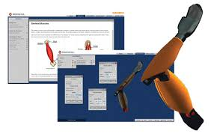
WhiteBox Learning is a web-based STEM learning system for grades 6-12 that brings real-world design to the classroom. Using the system’s 12 NGSS 3-Dimentional standards-aligned applications, students can design and analyze a 3-D model, learn through simulations, and conduct countless design iterations before building the physical model to complete the learning experience. Students can access, analyze, and save their designs anytime, anywhere. The system also allows students to collaborate with their peers on designs. It offers opportunities to participate in design competitions with fellow students in their school, district, and state, as well as across the country and world. WhiteBox Learning addresses various learning styles and provides all students with an engaging way to gain exposure to engineering design and the STEM career cluster for Career and Technical Education. WhiteBox Learning ‘s unique ability to allow for unlimited design iterations gives students a true real-world experience. Visit White Box Learning for more information.

FlinnSTEM®
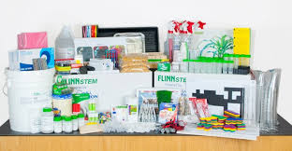
FlinnSTEM is a standards-aligned STEM curriculum for grades 4-8 that uses an engaging hands-on approach that guides students to explore new science concepts, connect to real-world experiences, and discover engineering design and scientific inquiry. Robust professional development is embedded in the program, giving educators everything, they need to teach STEM. FlinnSTEM’s professional development provides teachers with digital content, including background information, suggested inquiry approaches, point-of-use, professional learning videos, writable student activities and debrief questions. FlinnSTEM is adaptable to fit any learning environment. In the regular classroom, the program can be embedded in daily instruction and existing curriculum. FlinnSTEM is also perfect for outside the classroom, i.e., after-school programs and STEM-focused clubs. The units also provide content knowledge and hands-on experiences for student-driven projects in makerspace. Visit Flinn STEM for more information.

Science2Go
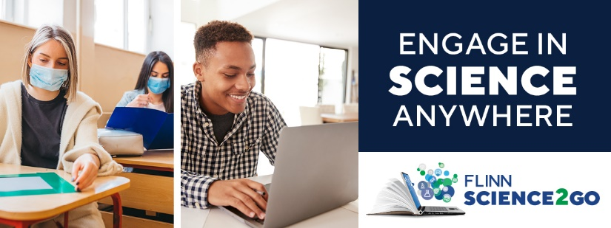
Science2Go is a digital learning solution that offers a new approach to laboratory education for middle school and high school students. It allows students to engage in science and engineering practices in any learning environment without access to supplies or equipment - making it a perfect solution for both in-classroom and distance learning. For in the classroom, Science2Go can be used as pre-lab work or lab work in social distancing classrooms where complete hands-on labs will not be done yet. Because the lab solutions are online, they are ideal for remote learning. Science2Go provides real lab experiments without the supplies. Students observe and refine experiments, identify design flaws, analyze data, and practice scientific reasoning while connecting science to the natural world.
- Videos focused on lab technique and data collection are combined with downloadable worksheets to engage students in science and engineering practices
- An easy-to-use implementation guide lets teachers get students up and running quickly, with students completing each lab in 30 minutes or less.
- Highly adaptable, the lab solutions are aligned with NGSS STANDARDS and other state science standards and can be used with any textbook curriculum.
- Each digital lab solution includes a recommendation for a hands-on lab kit, when needed.
High School Science Labs are based on main curriculum topics from four subject areas, namely Chemistry, Biology, Physics, & Environmental Science. Middle School Labs are based on main curriculum topics from two subject areas, namely Physical Science & Life Science.

360 Science®
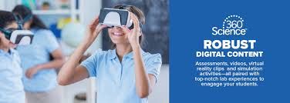
360 Science was born out of Flinn’s partnership with Pearson in the formation of their high school chemistry curriculum. The instructional approach is unique in that it begins each day with an inquiry lab supported with written research in a traditional textbook format. This approach intensifies the need for hands -on learning in the classroom and supports NGSS STANDARDS and other state sciences standards. Additionally, 360 Science includes a robust teacher management system that allows the instructor to customize lessons based on students’ skill sets and levels in the high school classroom, (i.e., college prep, honors, dual enrollment, and Advanced Placement courses.) With this differentiated (or leveled) learning, instructors can teach the same hands-on activity to students of different skill sets. 360 Science also includes a virtual reality component allowing students to engage deeper in the activities to get a truer understanding of science at the molecular level. With Flinn’s legacy of supporting teachers’ needs and putting safety first and foremost, all labs come with both print and digital instructions and safety guidelines and a teacher dashboard for classroom management and rostering. 360 Science is available today in an individual lab format, as a unique storyline experience solution, and as a district-wide offering with flexible pricing options. Visit 360 Science for more information.

FlinnPrep®
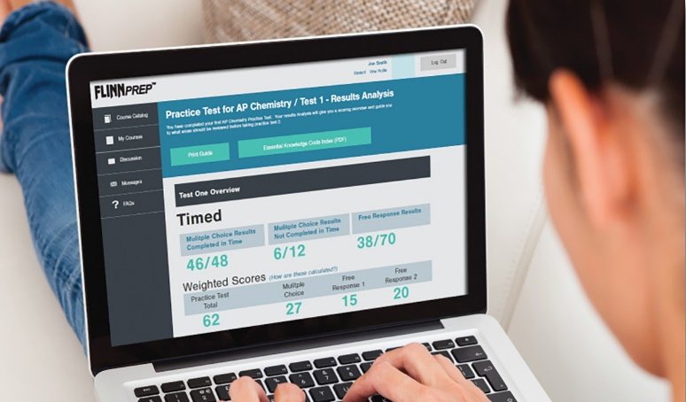
FlinnPrep is a complete learning solution that helps prepare and support students as they interact with the fast pace and rigor of Advanced Academic science courses. FlinnPrep is built to cover the full AP Curriculum, from the hands-on to the conceptual, all the way to the exam. The solution includes online courses and inquiry labs that are aligned with the College Board’s Big Ideas, Learning Objectives and Science Practices for AP, ensuring content that supports raising students’ AP test scores and preparing them for higher learning. Full-length practice exams are included to replicate the real AP exam experience. Covering Biology, Chemistry, Environmental Science, and Physics, each online course features easy-to-understand content, videos and animations that bring the content to life, competitive games to support review, and formative and summative assessments with just-in-time feedback. FlinnPrep’s flexible design and teacher center make it easy to personalize learning for students. Each inquiry lab includes two implementation paths, a low guided procedure to challenge advanced students with inquiry-based science and a high- guided procedure for students who need more direction, making the program applicable for students in dual-enrollment and honors courses. Visit FlinnPrep for more information.

Digital Dissection
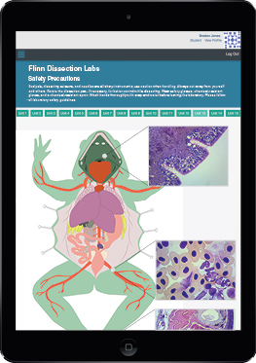
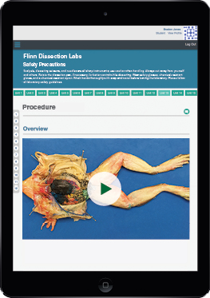
Flinn’s Digital Dissection Labs offers anywhere, anytime access to a dissection experience - without a specimen. This learning solution can be used as pre-lab practice, post-lab quizzing or as a dissection alternative when hands-on dissections cannot be done. Digital Dissection Labs comes with:
1.) Comprehensive Content & Tools that reinforce animal anatomy and dissection technique, including engaging text with video tutorials, detailed easy-to-understand background information , embedded questions to check for understanding, and interactive diagrams allowing students to explore the microscopic view of a larger organ or tissue;
2.) Drag-and-Drop Interactive Content that allows students to manipulate and explore an organism and connect the diagram to the actual specimen before the real thing in lab,
3.) Flexible Learning Options making the solutions suitable for a pre-dissection assignment or as a stand-alone dissection substitute – both options giving students the tools to tackle labs with confidence and
4.) Built-in safety guidelines and step-by-step instructions that ensure students have the knowledge they need to be successful and safe during lab. Engaging content and interactive tools reinforce animal anatomy and dissection technique. Six labs are available individually or as a convenient bundle. The six animals are Grass Frog, Fetal Pig, Perch, Sea Star, Earthworm, and Crayfish. Visit Digital Dissection for more information.

Personal Protective Equipment

To help schools prepare for a safe return to school, Flinn has personal protective equipment (PPE) in stock and additional inventory in route arriving throughout the summer, including masks, gloves, goggles, shields, and universal sanitizer for hands, furniture, and equipment. Flinn is ready to support district and school communities with everything from an opening day stock-up plan to a recurring safety kit for every school or classroom monthly. Many companies are quickly developing low-cost PPE alternatives that are not endorsed, approved, or tested. Trust that Flinn’s PPE goes through a rigorous testing process with Flinn scientists and product management to ensure the safety of all district and school communities. Below is a listing of supplies in stock and ready to ship. Visit Flinn Personal Protective Equipment more information.

Surgical Face Masks
Not all surgical masks are the same. ASTM certification is important when deciding what type of mask to use - The higher the ASTM level, the better. ASTM levels are:
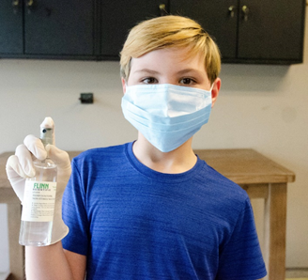
Level 1: the general standard for both surgical and procedural use offering the basic level of protection.
Level 2: moderate barrier protection for low-to-moderate levels of aerosols, sprays, and fluids.
Level 3: maximum barrier protection for any situation that has the potential for exposure to heavy levels of aerosols, sprays, and fluid (True medical/surgical mask)

When selecting any mask for use, consider the following four things; Filtration; Fluid Resistance; Features; Fitment. Flinn offers a three-ply surgical face mask that is made of non-woven material and is ASTM level 2 approved, providing the necessary protection while remaining light and comfortable. A full-width nosepiece guarantees proper fit. Latex-free ear loops are stretchy and non-irritating. Facial coverings like these masks are recommended safety items for everyone.

Woodbridge INOAC Filter Pore Foam Masks
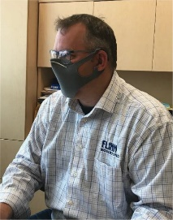
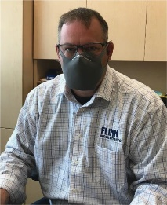
ASTM Level 3 (highest) certification for masks and Health Canada approved for medical/healthcare/long-term care facilities. Very low leakage on cheeks due to foam construction. Breathable and comfortable, this mask was designed by Woodbridge INOAC in Japan and Canada based on the use of industrial filtration foam technology, which is 100% non-latex and provides low breathing resistance. This mask is a comfortable ASTM Level 3 mask that can be worn for extended periods without causing discomfort. Complete with proprietary foam layer, inner filtration media and nose clip, the mask accommodates smaller and larger face sizes with selectable foam tab ear loops.

Nitrile Gloves
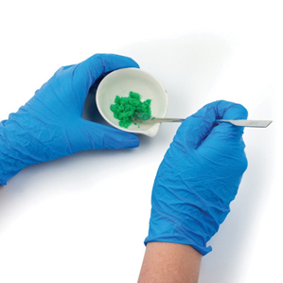
Flinn offers nitrile gloves that are approved by ASTM & FDA USA; TUV Germany; British Standard; and Australian Standard 4011. These gloves are also independently tested for tensile strength and aged tensile strength - passes both of these tests easily. Available in multiple sizes, these disposable yet durable gloves provide the “fit” and flexibility of disposable latex gloves. They offer superior protection against accidental contact with acids and bases or halogenated organic solvents while being made from hypoallergenic nitrile rubber. Pinhole-free material is 4 mils thick, these gloves resist tearing and will outlast common latex disposable gloves. The gloves are 9.5 inches long for standard medical / dental use and are 4mil thick with fingertip textured finish for dexterity. Note: Gloves should fit snug but not pinch or restrict movement. Remember to peel gloves from the wrist down, effectively turning the gloves inside out as you remove them. These gloves are sold in boxes of 100.

Universal Sanitizer
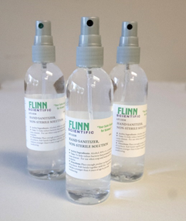
There are daily recalls of hand sanitizers made by non-certified organizations or those that contain dangerous chemicals such as methanol (methyl alcohol) or other ingredients. When selecting any hand sanitizer, know that there are two types of alcohol used: Ethanol and Isopropyl Alcohol. The CDC recommends ethanol (Like Flinn’s version) since isopropyl alcohol is volatile and cracks skin and is not recommended for children or the elderly. Flinn only uses the highest grade of ethanol for our custom hand sanitizers in gel or viscous formats. One-gallon and 55-gallon drums are available.

Face Shields
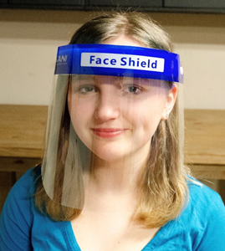
Flinn offers lightweight, medical quality, and easy-to-wear face shields that provide a protective barrier while allowing great visibility. These shields are perfect when a full-face option is needed for added protection. The soft spongy-foam forehead piece easily accommodates many face contours and the shield is re-usable. A practical item for both students and instructors alike, the shields work well for literacy and speech programs since they allow wearers to connect visually with the oral communication aspect of speech pathology and linguistics. The shields are manufactured in the United States.

IR Thermometers
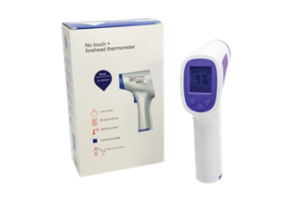
The IR Thermometer is useful to quickly take a temperature safely and with distance, helping to identify any person who may be starting to show symptoms of COVID-19. Some school districts will be taking IR thermometer readings before allowing students on the school bus, while others are checking every person at the main entrance to the school. These IR thermometers can be used either way.

Chemical Splash Safety Goggles and Sanitizer
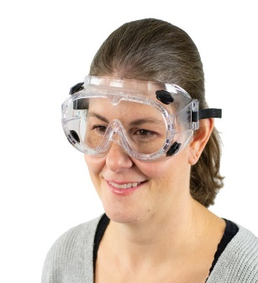
These chemical splash goggles are the perfect solution for full-coverage eye protection for lab safety for both students and instructors. They are fabricated from soft vinyl and conform to facial contours for maximum comfort and chemical protection, with the added benefit of keeping wearers from touching their eyes by accident. Plus, lenses are easily replaced, making these goggles an excellent investment. Goggles are ANSI Z87.1+ certified. They could be cleaned with disinfectant wipes, using a UV Goggle Sterilizer cabinet, and even with soap and water. Google options include Over the Glasses styles, Fog-Free Styles, Tall Lens Safety Glasses, Bio Glasses, VisorGogs and more. It is advised that districts have more googles than needed on-hand to maintain operations.
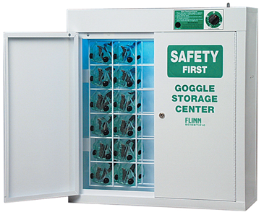
Flinn UV Goggle Sanitizer cabinets are designed to effectively clean googles in between uses. These sanitizers use a UV-C Germicidal bulb that emits very short ultraviolet wavelengths of light. Studies have shown that UV-C light damages the DNA of bacteria, viruses, and other pathogens to prevent replication. Manufactured to highest quality standards and used in schools for decades, Flinn’s cabinet system stores multiple pairs of goggles or safety glasses and includes a built-in safety system that only allows the unit to work when doors are closed and locked. These units are in high demand and are growing in popularity for mainstream classes – not just science labs.

Signage

Acrylic Barriers
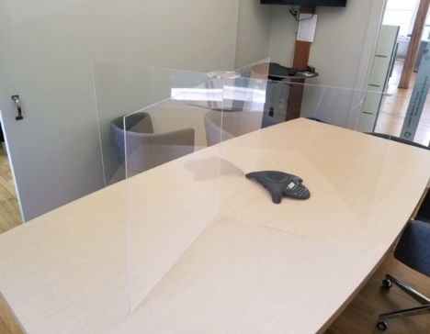
Sneeze guards and dividers provide a layer of defense to help prevent the spread of coronavirus and other airborne pathogens. Guards and dividers are a friendly way to protect your employees, customers, and visitors while still allowing for interpersonal interaction. Customized sizes are available and produced in the United States.

Laboratory Supplies & Science Resources

Equipment, Glassware, Chemicals
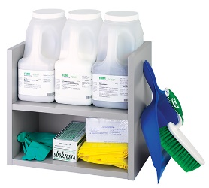
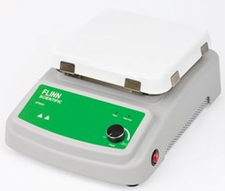
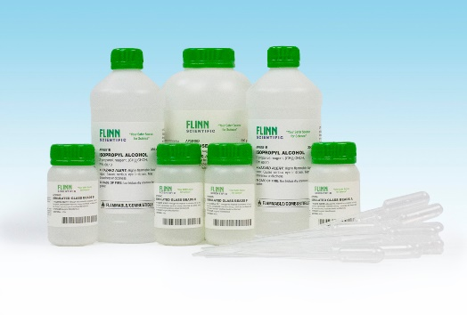
Educators rely on Flinn for quality laboratory supplies and equipment they need for effective teaching and learning. Teachers and students' results are impacted by the quality of the materials used in the science lab and Flinn's standards for product selection uphold those learning outcomes. Attention to lifetime product costs ensures results and value over the long-term. Capital equipment purchases are backed by Flinn's product warranties. Whether one is outfitting for a single lesson, a full science or STEM course, or the complete science department in a new school, Flinn's reputation of value, safety, and ease comprise an indelible experience.

Chemventory™
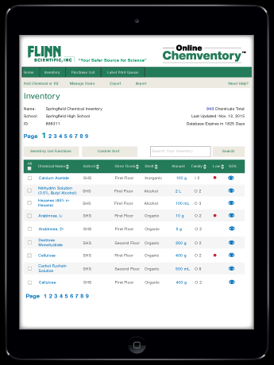
Flinn’s Online Chemventory™ is a secure cloud-based service that can be accessed by any computer or tablet with an internet connection, allowing convenient access to your Chemventory™ database from your chemical storeroom and classroom. Chemventory schools and districts have peace of mind knowing that their data is stored on a secure server remotely and can be easily accessed 24/7. Plus, it is simple to add Flinn chemicals to a Flinn Online Chemventory database by just looking up chemicals by keyword, catalog number, or alphabetical index and selecting what is in stock to add to the database. Do multiple teachers in the Science department share a storeroom? With Flinn Online Chemventory™ one database can be set up with multiple teachers, lab managers, and/or administrators invited to view or update the Chemventory™ database for no additional charge. Flinn Online Chemventory™ gives the flexibility to classify each chemical in inventory by the school name, chemical storeroom location, and shelf/cabinet location, allowing the ability by each of these categories. Additionally, Flinn has made it easy to set up multiple databases for schools with multiple chemical storeroom locations or multiple school locations and link access to users. New GHS pictograms and hazard information are included with every Flinn chemical in the Online Chemventory™ program - with the ability to print GHS pictograms and hazard statements on chemical labels. Visit https://chemventory.flinnsci.com/ for more information.

SciMatCo Storage Cabinets
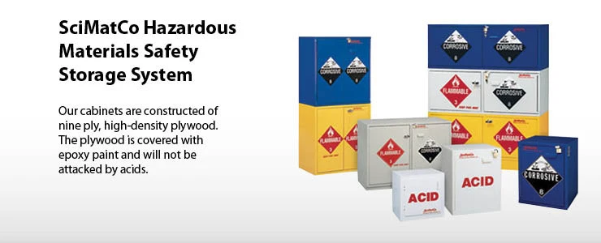
SciMatCo, A Flinn Scientific Company, manufactures and distributes non-metallic safety storage cabinets and related products. Founded in 1989 and based in Batavia, Illinois, SciMatCo offers a wide variety of high-quality options in various sizes and configurations for the safest storage of all types of hazardous materials. All SciMatCo products are proudly made in the United States and are distributed worldwide. Safety Storage cabinets are built specifically for the safe storage of hazardous chemicals or substances. These cabinets must be built using the correct materials and construction methods to safely isolate or protect volatile contents from each other or the effects of environmental hazards. SciMatCo Storage Cabinets offer:
- Safety – Wood and plastic cabinets do not react with acid or corrosives as metal cabinets do. Wood cabinets are the safest choices for flammables since wood is a thermal insulator.
- Long life – Wood or plastic cabinets last many years since they never rust or corrode. Rugged 1” exterior plywood construction withstands the most abusive environments.
- Code and standards compliant with cabinets that meet and exceed OSHA, NFPA, IFC and UFC standards – UL listed (flammables)
- An Extensive Product Line with cabinets in different sizes and configurations, bench-top and under-the counter (UTC) cabinets, stand-alone floor cabinets, space-saving stacking cabinets. Other types are combination cabinets, mobile cabinets, solid polypropylene cabinets, custom-made cabinets, as well as flammables cabinets, cabinets for acids and bases, corrosive cabinets, and general-purpose cabinets
For more information visit https://scimatco.com/

U-Design™ – Science & STEM Labs – Online Planner
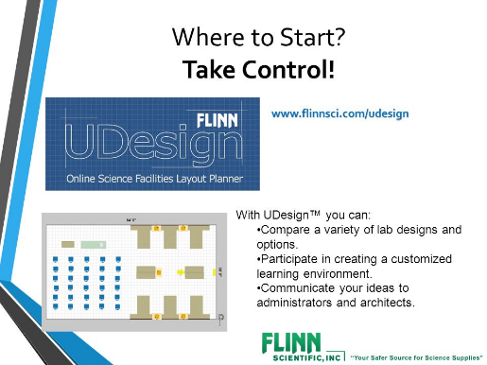
Optimizing new and renovated science or STEM rooms requires careful planning and preparation. Flinn’s experience and advice when planning these areas can help avoid the potential pitfalls that often plague science rooms, taking away the stress. U-Design™ is Flinn’s exclusive Science & STEM Room space planner. It is an interactive tool that is used to plan complete labs from an empty room to a room with fixtures, furniture, equipment, safety, and supplies. This free online tool prepares educators to have a voice in the planning process to completely design the ideal STEM or Science room. Completed designs produce an interactive counsel with Flinn’s planning team, a 2-D rendering, and a budgetary estimate for the space.

Customer Experience

Flinn Scientific is highly respected in the education industry because of its product quality and its commitment to service. Diligent project management is essential to achieve New Jersey districts’ goals. Flinn’s disciplined approach to managing the delivery of effective products and services ensures that all proposed tasks are accomplished with quality and accuracy, on schedule, and within budget. The key to the success of Flinn’s management plans is the provision of experienced, effective Project Leads, and an emphasis on the principles of open communication lines and teamwork.

Project Leads
Flinn proposes one Project Lead to oversee and coordinate all activities performed by the project team and to act as the channel for all project-related communications within Flinn and the district. This individual is empowered to guide and direct the team and ensure consistency, accuracy, and timeliness for all project work.
The Flinn Project Leader will also participate in management planning meetings and will communicate with the internal department on schedules and activities, participate in and facilitate meetings, and maintain ongoing relationships with district personnel and coordinators.

Communications Plan
Flinn is committed to high quality in all contract implementation activities. Flinn is proud of its national reputation for excellence in serving the education community and is dedicated to maintaining the highest level of quality in all our products and services. Flinn uses an open, direct, and ongoing communication model with all stakeholders during the implementation of products and services and incorporates the following operating principles and guidelines into the process:
- Partnering with all stakeholders effectively
- Open, direct, and regular communication between all parties; with a solid commitment to teamwork
- Effective coordination of project personnel and control of tasks
- Close adherence to schedule and deadlines
- Provision of high-quality products and outcomes
- Early identification of potential problems and appropriate intervention
- Maintenance of close communication with customers
- Progress reports are reviewed for cadence advances to pre-established mutually shared goals

Such communication will help to:
- Develop a more in-depth understanding of each district’s unique requirements
- Enhance services to help create strategies that address needs
- Work alongside in making recommendations to enhance program effectiveness and professional learning

Customer Care Team Lead
The customer team at Flinn Scientific is led by Michelle Jablonski. Michelle ensures all customers have a dedicated resource to address all operational questions from the time services are schedules and investments are made till the time the service is delivered and the solutions are implemented by an instructor or a Flinn representative. Even once the teachers are trained, students are rostered and products are on the shelves in the lab, a dedicated customer experience representative and team of scientists is there to answer questions throughout the school year.

Equipment and Warranty Service Contracts
It is imperative to maintain all warranties and ensure the proper operation of equipment. Flinn offers on-site maintenance contracts to maintain the proper working of all scientific equipment. Flinn provides a 5-Year Warranty on all Flinn Scientific and D-Lab branded equipment in our catalog.

Customized Packaging by Classroom / Instructor
Flinn’s recent warehouse transformation project is allowing customers to take advantage of reinforced box designs to better protect their investments. When Flinn pre-packages orders by classroom, laboratory, and instructor, districts save time, money, and resources, avoiding the bulk packaging that often causes unnecessary opening and repackaging of expensive equipment and fragile laboratory supplies. Flinn can take responsibility of the shipment and ensure it arrives on time, intact and ready for putting away and use by students and educators.

White Glove Service Option
Flinn’s on-the-ground support team has the skill, capability, and laboratory experience to receive, unpack, check in, and properly store the investment in new laboratory supplies. While on-site, the team will provide a free written science safety audit per school building and make any necessary requirements for the laboratory to ensure the safety and well-being of teachers and students. This audit will not only provide the necessary comfort of knowing a trusted partner is on your side, but also your insurance company will appreciate the added protection and, in many cases, offer a reduction in insurance premiums over time for maintaining ongoing safety protocols.

Science Essential Purchase Guide™ - Ordering made Easy
Ordering annually and outfitting science is optimized when using Flinn’s exclusive Science Essentials Purchase Guide™ as a handy tool. Featuring Teachers’ Choice products that are Flinn’s best-selling products, teachers are directed to those essentials needed when ordering. Used as a companion ordering tool, the guide is organized with science safety first, followed by common lab-ware and then discipline-specific products. This sequencing follows logically as prompts for the science essentials. The Purchase Guide is available in print, pdf and Excel versions for standardized ordering and communications, district-wide.

Flinn Overview
Official Registered Name: Flinn Scientific
Dun & Bradstreet Number: 08-521-7701
Address: 770 North Raddant Road, Batavia, IL 60510
Toll-Free Number: 800-452-1261
Fax Number: 866-452-1436
Flinn Scientific is currently an awarded a Statewide contract. This contract number is 17DPP00064 (T-0115).
Educational Data Services: 97909
Key Contacts:
Thomas Trapp Cameron Dummer

National Accounts Consultant
770 North Raddant Road
Batavia, IL 60510
ttrapp@flinnsci.com
402-960-5578 (Cell)
866-452-1436 (fax)

Account Executive
770 North Raddant Road
Batavia, IL 60510
cdummer@flinnsci.com
630-389-5062 (direct line)
866-452-1436 (fax)

Person Authorized to Contractually Bind Organization:

Daniel C. Cavalli
Chief Sales Officer
770 North Raddant Road
Batavia, IL 60510
732-759-7607
dcavalli@flinnsci.com

New Jersey teachers recognized that Flinn Scientific was indeed different from other companies. Here was a family-owned business that truly put the needs of its customers first! The most critical need was laboratory safety. Flinn Scientific responded by providing safely packaged chemicals, free safety training, and unique safety products. A teacher in New Jersey described Flinn’s leadership in promoting safety by writing, “Flinn alone has done more for safety in the science classrooms of America than legislators and educators combined.”

Our Mission
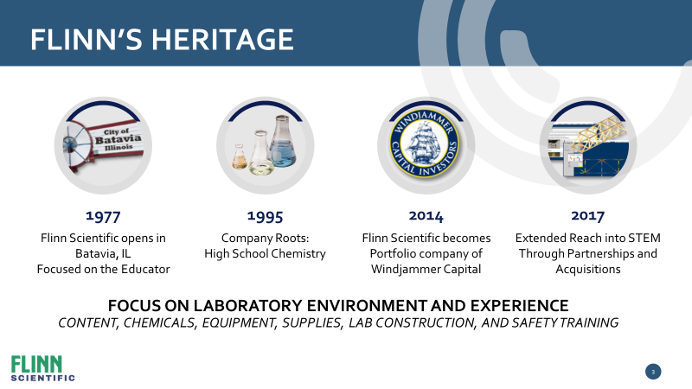
Flinn Scientific supports science educators in opening young minds to the challenges and joys of scientific discovery. We understand that science is a primary source of America’s unparalleled productivity, quality of life, and technological leadership. Through our unsurpassed customer service, we provide the science community with the very best education supplies, safety information, instructional materials, and programs to facilitate their vital work. Our respect for and loyalty to the science community is central to everything we do, and our relationship with them is always our priority.

Our Philosophy
To exceed customers’ expectations, our team provides the resources, tools, and training they need to be successful. Our goal is to make the customers’ role easier, safer, and more impactful through a “Customer First” experience. Our success is obtained primarily by how much we utilize our combined knowledge to anticipate and meet changing customer needs. We are committed to a culture and environment that is stimulating, challenging, and promotes individual growth. Leveraging our diverse talents to work together best enables us to develop and provide quality products and solutions that make a difference in the lives of students and educators. We achieve our goals through positive, supportive relationships and work environments based on truth and respect for the dignity of everyone. We believe creativity and innovation are critical in driving our ongoing success. Only with a financially strong and stable company that utilizes its resources effectively can we exceed the expectations of our customers, employees, and shareholders.

Our Core Values
Customer First | Understand and develop relationships with customers to anticipate and exceed their needs.
Value Creation | Achieve superior results by making more informed decisions through optimization, innovation, and expansion into new opportunities.
Respect | Treat others with honesty, dignity, respect, and sensitivity. Appreciate the value of diversity. Encourage and practice teamwork.
Knowledge Seek | Use and proactively share knowledge while embracing a constructive challenge process. Develop measures that lead to profitable action.
Change | Anticipate and embrace change. Envision what could be, challenge the status quo and empower teammates to engage in experimental discovery.
Development | Set high expectations for yourself and demonstrate the judgment, initiative, flexibility, teamwork, and critical-thinking skills necessary to make the greatest contribution to Flinn.
Humility | Exemplify humility and intellectual honesty. Constantly seek to understand and constructively deal with reality to create value and achieve personal improvement. Hold yourself and others accountable.
Integrity | Conduct all activities with integrity, for which courage is the foundation.
Fulfillment | Find satisfaction and meaning in your work by fully developing your capabilities to produce results that create the greatest value.

