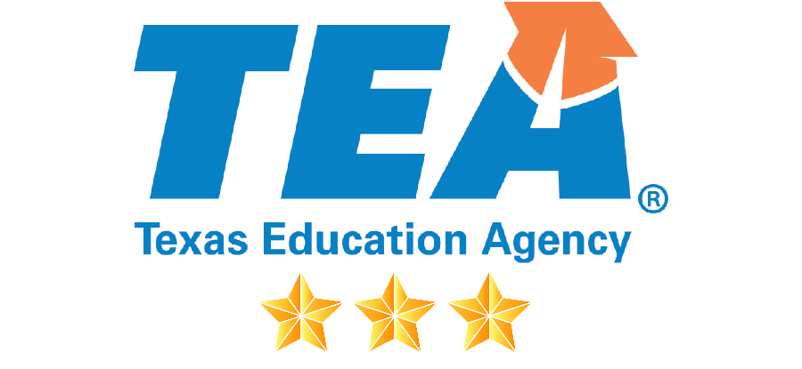

2020-2021
Elementary and Secondary
School Emergency Relief Grant

Flinn Scientific
Grant Alignment

Applications Due 5:00 p.m. CT, August 24, 2020

Submitted on Wednesday, January 22, 2020

Executive Summary 4
Ideal Partner for Texas Institutions 5
Trusted Name in School Safety 5
Partner in Science and STEAM Education 5
Customer Centric and Responsive 5
Standards-Aligned Support Products – TEKS 5
Alignment to ESSER Grant 6
Professional Learning Solutions 8
Covid-19 Guidance to Re-entry to Schools 8
Laboratory Safety in a Covid-19 Environment 8
Elementary Science and STEM Safety K-8 8
Prep Room COVID-19 Concerns 8
Chemventory™ & Science Safety Courses for Teachers™ 8
Blended Learning Solutions 9
WhiteBox Learning™ 9
FlinnSTEM® 9
Science2Go 10
360 Science® 10
FlinnPrep® 11
Digital Dissection 11
Personal Protective Equipment 13
Surgical Face Masks 13
Woodbridge INOAC Filter Pore Foam Masks 13
Nitrile Gloves 14
Universal Sanitizer 14
Face Shields 14
IR Thermometers 14
Chemical Splash Safety Goggles and Sanitizer 15
Signage 15
Acrylic Barriers 15
Laboratory Supplies & Science Resources 16
Equipment, Glassware, Chemicals 16
16
16
Chemventory™ 16
SciMatCo 16
U-Design™ – Science & STEM Labs – Online Planner 17
Customer Experience 18
Project Leads 18
Communications Plan 18
Customer Care Team Lead 19
Equipment and Warranty Service Contracts 19
Customized Packaging by Classroom / Instructor 19
White Glove Service Option 19
Science Essential Purchase Guide™ - Ordering made Easy 19
Flinn Overview 20
Our Mission 21
Our Philosophy 22
Our Core Values 22

Executive Summary

The Texas Education Agency (TEA) began accepting districts’ applications for the 2020-2021 Elementary and Secondary School Emergency Relief (ESSER) Grant on June 12, 2020. Flinn Scientific supports our Texas Educational partners and understand the time it takes to complete and work through these grant applications. The information included in this document is designed to fulfill these objectives:
- to help navigate the grant-writing process around the required re-opening activities,
- to support to required activities with Flinn solutions as included application addenda
- to support the challenges of remote science and STEAM education, and
- to provide the Texas education community with curated information on a safe back to school environment.
To ensure TEA's ability to expedite the processing of the ESSER grant applications and compliance with the federal reporting requirements for this grant, applicants should, to the greatest extent practicable, complete all sections of Application Part 1 (PDF), including the Signature of Authorized Official, electronically in the original PDF format. The Signature of Authorized Official section allows for digital signature (e-signature), which is preferred for this application.
Applications and signatures completed by hand, including applications that are scanned and submitted, will negate TEA's ability to electronically extract data and increase processing time of the application. Application data that cannot be extracted will be required (duplicative) in the first quarterly report.
Application Availability, Due Date, and Submission Requirements
Visit the TEA Grant Opportunities page for detailed information about the 2020-2021 Elementary and Secondary School Emergency Relief (ESSER) Grant Application. Search by the grant application name. Additional information on how to apply for a grant is available on the Applying for a Grant page.
Eligible applicants must apply by 5:00 p.m. Central Time, August 24, 2020.
Applicants must submit both Part 1 (PDF) and Part 2 (Excel) of the application to grantapplications@tea.texas.gov. The grant application will not be considered submitted unless both Part 1 and Part 2 are attached.

Ideal Partner for Texas Institutions
Flinn Scientific (Flinn) was created from a desire to serve science educators and has grown to become the trusted source for a safe return to schools and the leader in remote science and STEAM education. Our brand promise speaks for itself; Premium Quality, Exceptional Service, and Deep Scientific Expertise, Guaranteed!

Trusted Name in School Safety
Flinn Scientific supports science educators in opening young minds to the challenges and joys of scientific discovery. The leader in science lab supplies and safety, we provide learning systems and professional learning that incorporate differentiated digital experiences with hands-on learning to bring out the inner scientist in every student. America’s science teachers rely on Flinn’s leadership, reputation, and commitment to bring the best of science education solutions for their students.

Partner in Science and STEAM Education
Flinn Scientific creates programs and experiences that teach your students to think critically and evaluate information - building a passion for exploration and scientific inquiry. Additionally, programs: Are highly adaptable to suit students of various learning modalities, Incorporate inquiry-based principles, Take an applied approach that is grounded in the real-world, teaching skills in a way they will be used in the workforce and in real life, Establish a strong education and laboratory infrastructure focused on safety and Ensure science and STEAM is well integrated in your education system as a critical component for self-discovery

Customer Centric and Responsive
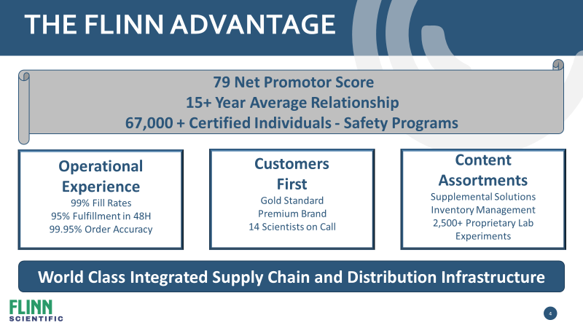
          - Strong brand equity and a legacy of understanding and fulfilling school districts and their educator’s needs
          - Net Promoter Score (79) results from responsiveness and attention to detail to both vendors’ and customers’ needs
          - Past, present, and future product roadmaps emphasize the importance of experiencing science in a blended learning environment
          - Flinn’s promise is: Premium Quality, Exceptional Service, and Deep Scientific Expertise, Guaranteed!

Standards-Aligned Support Products – TEKS
Flinn understands the importance of investing in only those science products that support an active laboratory experience where student achievement and teacher effectiveness is enhanced. Teaching and Learning environments to TEKS standards are enabled with the access to quality products that Flinn provides. Many of Flinn’s products align and support with instructive content, prescribed curriculum, and lesson plans that allow accelerated learning and comprehension.

Alignment to ESSER Grant
Allowable Activity | Flinn’s Alignment
1a. Any activity authorized under Elementary and Secondary Education Act (ESEA) | - Flinn’s Professional Learning  - Flinn’s Blended Learning Solutions  - Flinn’s Personal Protective, Equipment  - Flinn’s Laboratory Supplies and Science Resources
1b. Any activity authorized under Individuals with Disabilities Education Act (IDEA) | - Flinn’s Blended Learning Solutions  - Flinn’s Personal Protective, Equipment
1c. Any activity authorized under the Adult Education and Family Literacy Act | - Flinn’s Blended Learning Solutions
1d. Any activity authorized under the Carl D. Perkins Career and Technical Education Act of 2006 | - Flinn’s Professional Learning  - Flinn’s Blended Learning Solutions  - White Box Learning
1e. Any activity authorized under the Title VII, Subtitle B, McKinney-Vento Homeless Assistance Act | - Flinn’s Professional Learning  - Flinn’s Personal Protective, Equipment
2. Coordination of preparedness and response efforts of local educational agencies with state and local public health departments, and other relevant agencies, to improve coordinated responses among such entities to prevent, prepare for, and respond to coronavirus | - Flinn’s Professional Learning  - Flinn’s Blended Learning Solutions  - Flinn’s Personal Protective, Equipment  - Flinn’s Laboratory Supplies and Science Resources
3. Providing principals and other school leaders with the resources necessary to address the needs of their individual schools | - Flinn’s Professional Learning  - Flinn’s Blended Learning Solutions  - Flinn’s Personal Protective, Equipment  - Flinn’s Laboratory Supplies and Science Resources
4. Activities to address the unique needs of low-income children or students, children with disabilities, English learners, racial and ethnic minorities, students experiencing homelessness, and foster care youth, including how outreach and service delivery will meet the needs of each population | - Flinn’s Professional Learning  - Flinn’s Blended Learning Solutions  - Flinn’s Personal Protective, Equipment  - Flinn’s Laboratory Supplies and Science Resources
5. Developing and implementing procedures and systems to improve the preparedness and response efforts of local educational agencies | - Flinn’s Professional Learning
6. Training and professional development for staff of the local educational agency on sanitization and minimizing the spread of infectious diseases | - Flinn’s Professional Learning  - Flinn’s Personal Protective, Equipment
7. Purchasing supplies to sanitize and clean the facilities of a local educational agency, including buildings operated by such agency | - Flinn’s Professional Learning  - Flinn’s Personal Protective, Equipment  - Flinn’s Laboratory Supplies and Science Resources
8a. Planning for and coordinating during long-term closures, including for how to provide meals to eligible students | - Flinn’s Professional Learning  - Flinn’s Blended Learning Solutions
8b. Planning for and coordinating during long-term closures, including for...how to provide technology for online learning to all students | - Flinn’s Professional Learning  - Flinn’s Blended Learning Solutions
Allowable Activity | Flinn Alignment
8c. Planning for and coordinating during long-term closures, including for...how to provide guidance for carrying out requirements under the Individuals with Disabilities Education Act (20 U.S.C. 1401 et seq) | - Flinn’s Professional Learning  - Flinn’s Blended Learning Solutions
8d. Planning for and coordinating during long-term closures, including for...how to ensure other educational services can continue to be provided consistent with all Federal, State, and local requirements | - Flinn’s Professional Learning  - Flinn’s Blended Learning Solutions
9. Purchasing educational technology (including hardware, software, and connectivity) by students who are served by the local educational agency that aids in regular and substantive educational interaction between students and their classroom instructors, including low-income students, and students with disabilities, which may include assistive technology or adaptive equipment | - Flinn’s Professional Learning  - Flinn’s Blended Learning Solutions
10. Providing mental health services and supports | - Flinn’s Professional Learning
11a. Planning and implementing activities related to summer learning...including providing classroom instruction or online learning during the summer months and addressing the needs of low-income students, students with disabilities, English learners, migrant students, students experiencing homelessness, and children in foster care | - Flinn’s Professional Learning  - Flinn’s Blended Learning Solutions  - Flinn’s Personal Protective, Equipment  - Flinn’s Laboratory Supplies and Science Resources
11b. Planning and implementing activities related to... supplemental afterschool programs, including providing classroom instruction or online learning...addressing the needs of low-income students, students with disabilities, English learners, migrant students, students experiencing homelessness, and children in foster care | - Flinn’s Professional Learning  - Flinn’s Blended Learning Solutions  - Flinn’s Personal Protective, Equipment  - Flinn’s Laboratory Supplies and Science Resources
12a. Other activities that are necessary to maintain the operation of, and continuity of, services in local educational agencies | - Flinn’s Professional Learning  - Flinn’s Personal Protective, Equipment
12b. Other activities that are necessary to...continuing to employ existing staff of the local educational agency | - Flinn’s Professional Learning  - Flinn’s Personal Protective, Equipment

Professional Learning Solutions
Flinn Scientific knows that training is crucial not only related to the implementation of all curriculum resources but also for all stakeholders involved in returning to school safely in late Summer and early Fall. Therefore, it is of the utmost importance to elevate the skills of the personnel involved in this initiative with ongoing professional learning. To this end, we will work with all Texas institutions to tailor the training sessions and delivery methods that will meet your needs. https://www.flinnsci.com/professional-learning/

Covid-19 Guidance to Re-entry to Schools
There is an overwhelming amount of information available on returning to school safely and we know your time is limited. The education and safety professionals at Flinn have created this guide curating the key pieces of information designed to help as you plan for what lies ahead. This is a time for safety and for education. FLINN recognizes that there is not a ‘one-size fits all’ solution to safely returning to school, which is why we are suggesting that you participate in this session to get the facts, the links, and the information that you need

Laboratory Safety in a Covid-19 Environment
Come spend some time with FLINN on a guided tour of the science department and we will investigate some common safety protocols and best-practices. We will look at the use of safety contracts, chemical handling, storage, labelling, hazardous chemicals, PPE, chemical spills, fires, floods, broken glass, accidental injury and more. Let a trained Flinn Safety Expert increase your safety awareness in your lab and prep room.

Elementary Science and STEM Safety K-8
Flinn has been recognized as the leader in science safety since 1977. Let us take you on a journey through the elementary science and STEM lab towards increased safety and compliance. We will look at the safe, proper use and storage of science equipment, apparatus, hand tools, and more in addition to some checklists and things to watch for with your students. Flinn is your trusted lab partner in your elementary school!

Prep Room COVID-19 Concerns
We recognize that you may not have had enough time to organize your prep room when you were told to ‘Shelter in Place’ back in March. Let Flinn help you identify some areas of concern since it is likely that nobody has been in the school or into the prep room for three months. We will discuss common issues that exist such as chemical storage, dissection storage, waste pick-up, and many other relevant concerns for science educators.

Chemventory™ & Science Safety Courses for Teachers™
Conducting science lab activities safely and managing chemicals and hazardous materials in your schools requires the right tools for inventory and safety training. Flinn offers both in our exclusive Science Safety Courses™ for teachers and Chemventory™ to assist with the management of Professional Development and Regulatory Compliance for your science teachers and schools. Education is our best preventative measure to reduce the risk of accidents in the classroom and laboratory. Optimized science safety at Flinn includes our exclusive 7-Star Science Safety Solution consisting of: 1.) Science Safety Teacher Training & Certification – on-site, on-line, or on-demand, 2.) Science Room Safety Self-Inspections, 3.) Chemventory™ for Responsible Chemical Management, 4.) Student Safety Contracts, 5.) Departmental Safety Notes & Calendar, 6.) Annual Science Safety Reviews, and 7.) Science Safety First Inventory & Science Essentials Purchase Guide. This solution is unparalleled for districts seeking the premier science safety solution in education.

Blended Learning Solutions
Flinn Scientific’s blended solutions support existing district-adopted lab experiences, offers blended learning and distance-learning options, aligns with 3-Dimensional Learning standards, employs differentiated learning, and provides anytime – anywhere access to the learning platform. Flinn’s offers support for advanced academics in the sciences; biology, chemistry, physics, and environmental science combined with addressing the multi-modality of learners through a series of educational videos, virtual reality, research based journals, hands-on inquiry labs, and professional development to train educators how to incorporate STEAM based education alignment into the core subject areas. This alignment along with the real-world storylines and reference of career pathways support the development of learning beyond the classroom, tied to various professions along with the opportunity to experience the design thinking process while allowing the learners to accept failure and learn from their exploration of discovery. A listing of these solutions is below.

WhiteBox Learning™
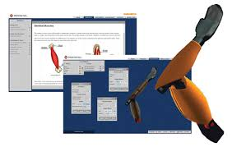
WhiteBox Learning is a web-based STEM learning system for grades 6-12 that brings real-world design to the classroom. Using the system’s 12 Next Generation Science Standards-aligned applications, students can design an analyze a 3-D model, learn through simulations, and conduct countless design iterations before building the physical model to complete the learning experience. Students can access, analyze, and save their designs anytime, anywhere. The system also allows students to collaborate with their peers on designs and offers opportunities to participate in design competitions with fellow students in their school, district, and state, as well as across the country and world. WhiteBox Learning addresses various learning styles and provides all students with an engaging way to gain exposure to engineering design and the STEM career cluster for Career and Technical Education.
WhiteBox Learning ‘s unique ability to allow for unlimited design iterations is a critical process in giving students a real-world experience. www.whiteboxlearning.com

FlinnSTEM®
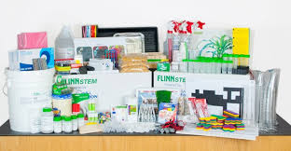
FlinnSTEM is a standards-aligned STEM curriculum for grades 4-8 that uses an engaging hands-on approach to guide students to explore new science concepts, connect to real-world experiences, and discover engineering design and scientific inquiry. Robust professional development is embedded in the program, giving educators everything, they need to teach STEM. FlinnSTEM professional development provides teachers with great digital content, including background information, suggested inquiry approaches, point-of-use, professional development videos, writable student activities and debrief questions.
FlinnSTEM is adaptable to fit any learning environment. In the regular classroom, the program can be embedded in daily instruction and existing curriculum. FlinnSTEM is also perfect for outside the classroom, like after-school programs and STEM-focused clubs. The units also provide content knowledge and hands-on experiences for student-driven projects in makerspace. www.flinnstem.com

Science2Go
Science2Go is a digital learning solution that offers a new approach to laboratory education for middle school and high school students. It allows students to engage in science and engineering practices in any learning environment without access to supplies or equipment - making it a perfect solution for both in-classroom and remote learning. The Science2Go Approach - Science2Go lets students experience the laboratory component of science in any learning environment. Science2Go enables learning that bridges the classroom to home - and back! It can be used in-school use as pre-lab work or in social distancing classrooms where complete hands-on labs will not be done yet. Because the lab solutions are online, they are ideal for remote learning.
Science2Go provides real lab experiments without the supplies.
Students observe and refine experiments, identify design flaws, analyze data, and practice scientific reasoning while connecting science to the natural world.
- Videos focused on lab technique and data collection are combined with downloadable worksheets to engage students in science and engineering practices
- An easy-to-use implementation guide lets teachers get students up and running quickly, with students completing each lab in 30 minutes or less.
- Highly adaptable, the lab solutions are aligned with NGSS and other state science standards and can be used with any textbook curriculum.
- Each digital lab solution includes a recommendation for a hands-on lab kit, when needed.
High School Science Labs
Lab solutions include videos and downloadable and editable content based on main curriculum topics from four subject areas: Chemistry, Biology, Physics, & Environmental Science
Middle School Labs
Lab solutions include videos and downloadable and editable content based on main curriculum topics from two subject areas. Physical Science & Life Science

360 Science®
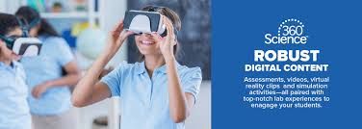
360 science was born out of our partnership with Pearson in the formation of their high school chemistry curriculum. Their instructional approach is unique in that it begins each day with an inquiry lab supporting that with written research in a traditional textbook format. This approach intensifies the need for hands -on learning in the classroom and supports NGSS and associated science state standards. 360 science goes beyond the curriculum instruction to include a robust teacher management system that allows the instructor to customize the lessons based on students’ skill set and level in the high school classroom, for example, college prep, honors, dual enrollment, and Advanced Placement courses. 360 Science differentiated (or leveled) learning allows instructors to teach the same hands-on activity to students of different skill sets. The virtual reality component allows students to engage deeper in the activities and get a truer understanding of science at the molecular level. Flinn’s legacy is to think about the teachers’ needs and safety first and foremost, so all labs come with both print and digital instructions and safety guidelines and that all-important teacher dashboard for classroom management and rostering. This learning solution is available today in individual lab format, as a unique story line experience solution, and as a district-wide offering with flexible pricing options. https://www.flinnsci.com/learning-solutions/360Science/

FlinnPrep®
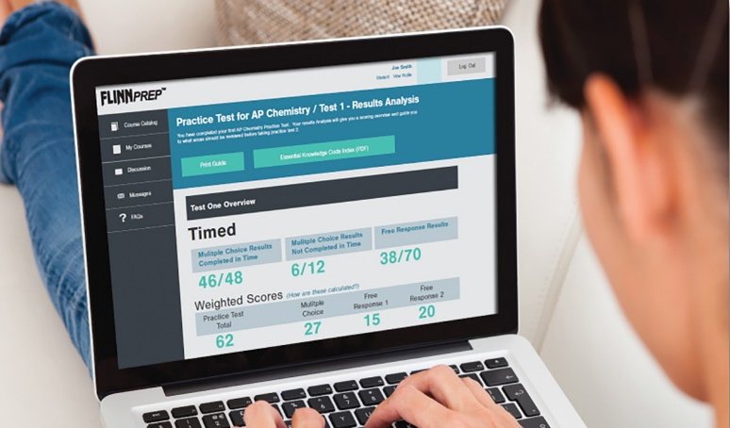
FlinnPrep is a complete learning solution that helps prepare and support students as they interact with the fast pace and rig or of Advanced Academic science courses. With online courses and inquiry labs, it is built to cover the full Curriculum, from the hands-on to the conceptual, all the way to the exam. FlinnPrep’s courses and inquiry labs are aligned with the College Board’s Big Ideas, Learning Objectives and Science Practice for AP Curriculum, ensuring content that supports raising students’ AP test scores and preparing them for higher learning. Full-length practice exams are included to replicate the real AP exam experience. Covering Biology, Chemistry, Environmental Science, and Physics, each online course features easy-to-understand content, videos and animations that bring the content to life, competitive games to support review, formative and summative assessments with just-in-time feedback, and full-length practice exams. Its flexible design and teacher center make it easy to personalize learning for students. Each lab includes two implementation paths, a low guided procedure to challenge advanced students with inquiry-based science and a high- guided procedure for students who need more direction, making the program applicable for students in dual-enrollment and honors courses. www.flinnprep.com

Digital Dissection
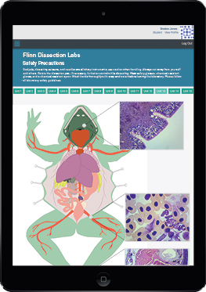
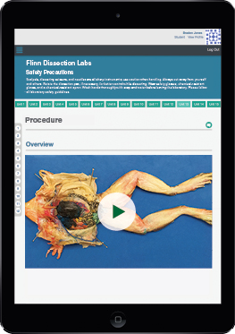
Enjoy anywhere, anytime access to Flinn Digital Dissection Labs! These dissection study tools can be used as prelab practice, post lab quizzing or even as dissection alternatives. Engaging content and interactive tools reinforce animal anatomy and dissection technique. Six labs are available individually or as a convenient bundle. Comprehensive Content & Tools - Engaging text with clear, simple diagrams and video tutorials help students get the most out of their dissection experience. Detailed background information is included on each species and written for students, so it is easy to understand. Questions to check for understanding are built into the content to drive home important techniques and concepts. Interactive diagrams allow students to explore the microscopic view of a larger organ or tissue. Drag-and-Drop Interactive Content - Practice before lab with interactive drag-and-drop tools that allow students to manipulate and explore an organism before the real thing in lab. Anatomical features and organs can be picked up and moved around to help connect the diagrams to the actual specimen. May also be used as a dissection alternative. Flexible Learning Options - Use as a pre-dissection assignment or as a stand-alone dissection substitute. Students can watch and practice at home to learn so they arrive in lab confident and ready to tackle the science at hand. If they get stuck during lab or have trouble finding a structure, the video tutorials are there to help. Built-in safety guidelines and step-by-step instructions ensure that students have the knowledge they need to be successful and safe during lab. Explore all six animals: Grass Frog, Fetal Pig, Perch, Sea Star, Earthworm, and Crayfish. https://www.flinnsci.com/flinn-digital-dissection-labs-1-year-access/

Personal Protective Equipment

Flinn has personal protective equipment (PPE) in stock and additional inventory in route arriving throughout the summer. Masks, gloves, goggles, and universal sanitizer for hands, furniture, and equipment: we will support your community with everything from an opening day stock-up plan to a recurring safety kit for every school or classroom monthly. We anticipate extraordinary demands for these safety products as schools prepare to re-open safely. Do not be fooled by low cost imitations of masks, gloves, and shields. Companies who are not experts are quickly developing low cost alternatives which are not endorsed, approved, or tested. Rest assured all products go through a rigorous testing process with Flinn scientists and product management to ensure your communities are safe. We trust you will do the same. Here is a listing of supplies in stock and ready to ship: https://www.flinnsci.com/ppe/

Surgical Face Masks
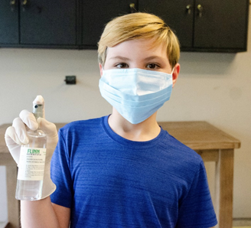
ASTM certification is important and relevant when deciding what type of mask to use:
Level 1: the general standard for both surgical and procedural use. Basic level of protection.
Level 2: moderate barrier protection for low-to-moderate levels of aerosols, sprays, and fluids.
Level 3: maximum barrier protection for any situation that has the potential for exposure to heavy levels of aerosols, sprays, and fluids. (True medical/surgical mask)
When selecting any mask for use, consider the following four things; Filtration; Fluid Resistance; Features; Fitment. Make sure that you are using the appropriate mask for the conditions that you are in – and remember that the higher the ASTM level, the better it is. Not all surgical masks are the same. This three-ply surgical face mask is made of non-woven material and is ASTM level 2 approved, providing necessary protection while remaining light and comfortable. A full-width nosepiece guarantees proper fit. Latex-free ear loops are stretchy and non-irritating. Facial coverings like these masks are recommended safety items for everyone.

Woodbridge INOAC Filter Pore Foam Masks
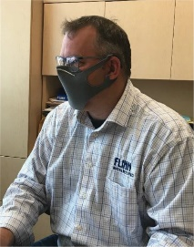
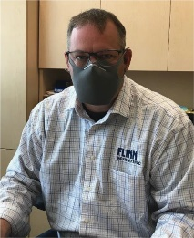
ASTM Level 3 (highest) certification for masks and Health Canada approved for medical/healthcare/long-term care facilities. Very low leakage on cheeks due to foam construction. Breathable and comfortable. This mask was designed by Woodbridge INOAC in Japan and in Canada based on the use of industrial filtration foam technology which is 100% non-latex and provides low breathing resistance. This is a comfortable ASTM Level 3 mask that can be worn for extended periods of time without causing discomfort. Complete with proprietary foam layer, inner filtration media and nose clip. Accommodates smaller and larger face sizes with selectable foam tab ear loops.

Nitrile Gloves
These gloves are approved by ASTM & FDA USA; TUV Germany; British Standard; Australian Standard 4011. These are also independently tested for tensile strength and aged tensile strength and passes both easily. Available in multiple sizes, these disposable yet durable gloves provide the “fit” and flexibility of disposable latex gloves while offering superior protection against accidental contact with acids and bases or halogenated organic solvents while being made from hypoallergenic nitrile rubber. Pinhole-free material is 4 mils thick, these gloves resist tearing and will outlast common latex disposable gloves. 9.5 inches long for standard medical / dental use and are 4mil thick with fingertip textured finish for dexterity. Gloves should fit snug but not pinch or restrict movement. Remember to peel gloves from the wrist down, effectively turning the gloves inside out as you remove them. Sold in boxes of 100.

Universal Sanitizer
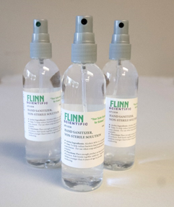
There are daily recalls of hand sanitizers made by non-certified organizations or those that contain dangerous chemicals such as methanol (methyl alcohol) or other ingredients. Flinn only uses the highest grade of ethanol for our custom hand sanitizers in gel or viscous formats. 1 gallon, and 55-gallon drums available.
When selecting any hand sanitizer know that there are two types of alcohol used: Ethanol and Isopropyl Alcohol. THE CDC recommends ethanol (Like Flinn’s version) since isopropyl alcohol is volatile and cracks skin and is not recommended for children or the elderly

Face Shields
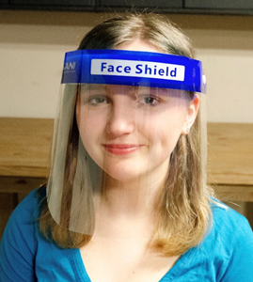
Looking for a comfortable, medical quality face shield? Look no further. These lightweight and easy-to-wear face shields offer a protective barrier while allowing great visibility. Perfect when you need a full-face option for added protection. The soft spongy-foam forehead piece easily accommodates many face contours and the shield is re-usable. Nice and lightweight, these are a practical item for both students and instructors alike. Great for literacy and speech programs since they allow you to connect visually with the oral communication aspect of speech pathology and linguistics. These new ones are manufactured here in the USA!

IR Thermometers
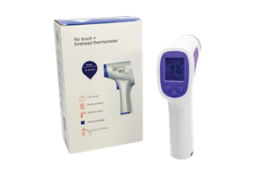
The IR Thermometer is useful for quickly taking a temperature safely and with distance. This device will help identify any person who may be starting to show symptoms of COVID-19. We have heard that some school districts will be taking IR thermometer readings before allowing students on the school bus…. Others are checking every person at the main entrance to the school to make sure that you are healthy.

Chemical Splash Safety Goggles and Sanitizer
Chemical splash goggles for lab safety are fabricated from a soft vinyl and conform to facial contours for maximum comfort and chemical protection, with the added benefit of keeping you from touching your eyes by accident. The perfect solution for full coverage eye protection. Lenses are easily replaced making these goggles a great investment. Goggles are ANSI Z87.1+ certified and are useful for both students and instructors. Can be cleaned with disinfectant wipes. UV Goggle Sterilizer cabinets and even soap and water. There are options to consider – Over the Glasses styles; Fog-Free Styles; Tall Lens Safety Glasses, Bio Glasses, VisorGogs and more! Make sure that your district has more than they anticipate needing on-hand to start and maintain your operations.
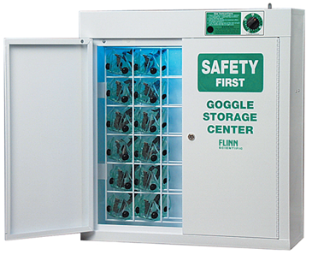
Our Flinn UV goggle sanitizers are designed to effectively clean googles in between uses. These sanitizers use a UV-C Germicidal bulb that emits very short ultraviolet wavelengths of light. Studies have shown that UV-C light damages the DNA of bacteria, viruses, and other pathogens to prevent replication. The system stores multiple pairs of goggles or safety glasses. Manufactured to the highest quality standards and have been used in schools for decades. Safety system built-in that only allows unit to work when doors are closed and locked. Very high demand for these unit across North America and growing in popularity for mainstream classes – not just science labs!

Signage

Acrylic Barriers
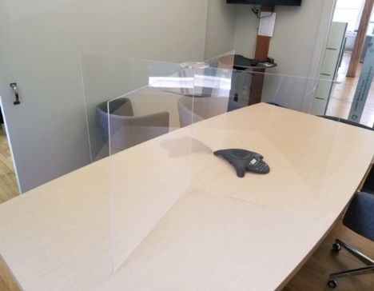
Sneeze guards and dividers provide a layer of defense to help prevent the spread of coronavirus and other airborne pathogens. Guards and dividers are a friendly way to protect your employees, customers, and visitors while still allowing for interpersonal interaction. Customized sizes available, produced in the United States.

Laboratory Supplies & Science Resources

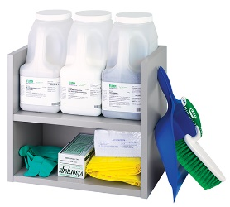
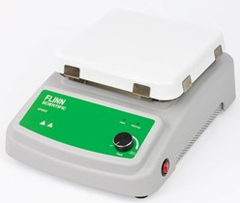
Equipment, Glassware, Chemicals
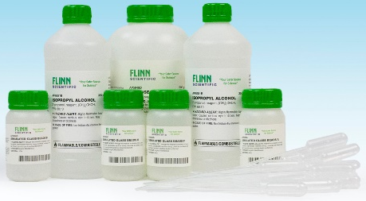

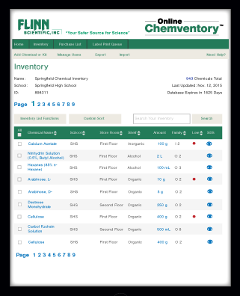
Chemventory™
Flinn’s Online Chemventory™ is a secure cloud-based service that can be accessed by any computer or tablet with an internet connection, allowing convenient access to your Chemventory™ database from your chemical storeroom and classroom. With Chemventory you will have peace of mind knowing that your data is stored on a secure server remotely and can be easily accessed 24/7. Plus, it is simple to add Flinn chemicals to your Flinn Online Chemventory database by just looking up chemicals by keyword, catalog number, or alphabetical index and selecting what you have in stock to add to your database. Do you share a storeroom with other teachers in your department? With Flinn Online Chemventory™ you can setup one database and invite other teachers, lab managers, and/or administrators to view or update your Chemventory™ database for no additional charge. Flinn Online Chemventory™ gives you the flexibi lity to classify each chemical in your inventory by the school name, chemical storeroom location, and shelf/cabinet location. You can then sort your list by each of these categories. If your school has multiple chemical storeroom locations, or your school district has multiple school locations it will be more manageable to keep chemical inventory files in more than one Chemventory™ database. Flinn has made it easy to set-up multiple databases and link access to users. We have included new GHS pictograms and hazard information with every Flinn chemical in our Online Chemventory™ program. GHS pictograms and hazard statements can also be printed on chemical labels through the Online Chemventory™ program. https://chemventory.flinnsci.com/

SciMatCo
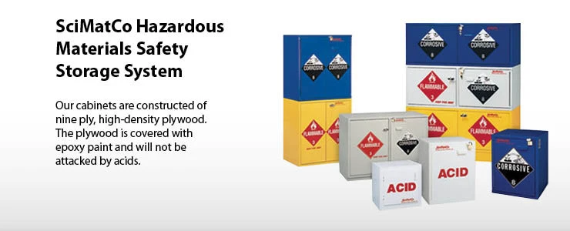
SciMatCo, A Flinn Scientific Company, manufactures and distributes non-metallic safety storage cabinets and related products. Founded in 1989 and based in Batavia, Illinois, SciMatCo offers a wide variety of high-quality options in various sizes and configurations for the safest storage of all types of hazardous materials. All SciMatCo products are proudly made in the USA and are distributed worldwide. What is a Safety Storage Cabinet? A cabinet built specifically for the safe storage of hazardous chemicals or substances. Safety storage cabinets must be built using the correct materials and construction methods to safely isolate or protect volatile contents from each other or from the effects of environmental hazards.
Why Choose SciMatCo Storage Cabinets?
- Safety – Our wood and plastic cabinets do not react with acid or corrosives as metal cabinets do. – Wood cabinets are the safest choices for flammables since wood is a thermal insulator.
- Long life – Wood or plastic cabinets last many years since they never rust or corrode. – Rugged 1” exterior plywood construction withstands the most abusive environments.
- Code and standards compliant – Meet and exceed OSHA, NFPA, IFC and UFC standards – UL listed (flammables) • Different sizes and configurations – Benchtop and Under-the counter (UTC) cabinets – Stand-alone floor cabinets – Space saving stacking cabinets – Combination Cabinets – Mobile Cabinets – Solid Polypropylene Cabinets – Custom Made Cabinets
- Extensive product line – Flammables cabinets – Cabinets for Acids and bases – Corrosive cabinets – General purpose cabinets
For more information please visit: https://scimatco.com/

U-Design™ – Science & STEM Labs – Online Planner
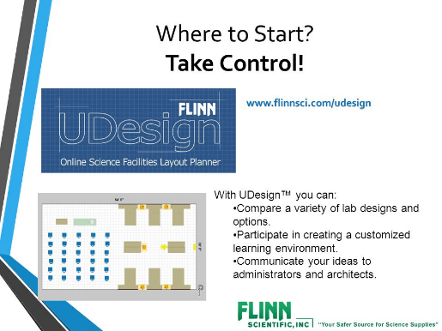
Optimizing New and Renovated science or STEM rooms requires careful planning and preparation. Flinn’s experience and advice when planning these areas is a wise counsel to avoid the potential pitfalls that often plague science rooms for decades. Throughout the planning process, Flinn offers advice at each stage for appropriate space-planning, configurations, 21st Century learning recommendation, digital solutions, fixtures, furniture & Equipment (FF&E), optimized outfitting with supplies, and the services that take away the stress of opening new spaces. U-Design™ is Flinn’s exclusive Science & STEM Room space planner that is an interactive tool to be used to plan complete labs from an empty room with the fixtures, furniture, equipment, safety, and supplies. This free online tool prepares educators to have a voice in the planning process and may be used to completely design the ideal STEM or Science room. Completed designs produce an interactive counsel with our planning team, a 2-D rendering, and a budgetary estimate for the space.

Customer Experience

Flinn Scientific is highly respected in the education industry because of the quality of our products and our commitment to service. We are fully aware that to achieve Texas District’s goals, diligent project management is essential. Flinn’s disciplined approach to managing the delivery of effective products and services ensures that all proposed tasks are accomplished with quality and accuracy, on schedule, and within budget. The key to the success of our management plans is the provision of experienced, effective Project Leads, and an emphasis on the principles of open communication lines and teamwork.

Project Leads
Flinn proposes one Project Lead to oversee and coordinate all activities performed by the project team and to act as the channel for all project-related communications within Flinn and your district. This individual will be empowered to guide and direct the team and ensure consistency, accuracy, and timeliness for all project work.
Our Project Leader will also participate in management planning meetings and will communicate with the internal department on schedules and activities, participate in and facilitate meetings, and maintain ongoing relationships with district personnel and coordinators.

Communications Plan
Flinn is committed to high-quality in all contract implementation activities. We are proud of our well-earned national reputation for excellence in serving the education community, and we are dedicated to maintaining the highest level of quality in all our products and services. We will use an open, direct, and ongoing communication model with all stakeholders during the implementation of our products and services and incorporate the following operating principles and guidelines into our processes:
- Partnering with all stakeholders effectively
- Open, direct, and regular communication between all parties; with a solid commitment to teamwork
- Effective coordination of project personnel and control of tasks
- Close adherence to schedule and deadlines
- Provision of high-quality products and outcomes
- Early identification of potential problems and appropriate intervention
- Maintenance of close communication with customers
- Progress reports are reviewed for cadence advances to pre-established mutually shared goals

Such communication will help us to:
- Develop a more in-depth understanding of each district’s unique requirements
- Enhance services to help create strategies that address needs
- Work alongside in making recommendations to enhance program effectiveness and professional learning

Customer Care Team Lead
The customer team at Flinn Scientific is led by Michelle Jablonski. Michelle ensures all customers have a dedicated resource to address all operational questions from the time services are schedules and investments are made till the time the service is delivered and the solutions are implemented by an instructor or a Flinn representative - Even once the teachers are trained, students are rostered and products are on the shelves in the lab, a dedicated customer experience representative and team of scientists will be with you to answer questions throughout the school year. Additional services available through Flinn Scientific:

Equipment and Warranty Service Contracts
The importance of ongoing maintenance to most of the equipment is imperative to maintaining all warranties and ensuring the proper operation of the equipment. Flinn offers onsite maintenance contracts to maintain the proper working of all scientific equipment. Flinn provides a 5 Year Warranty on all Flinn Scientific and D-Lab branded equipment in our catalog.

Customized Packaging by Classroom / Instructor
Flinn’s recent warehouse transformation project is allowing our customers to take advantage of our reinforced box designs to better protect your investments. When Flinn pre-packages your orders by classroom, laboratory, and instructor, this will save your district time, money, and resources, avoiding the bulk packaging to be delivered to your district warehouse, causing unnecessary opening and repackaging of expensive equipment and fragile laboratory supplies. Flinn can take responsibility of the shipment and ensure it arrives on time, intact and ready for putting away and use by your students and educators.

White Glove Service Option
Flinn’s on-ground support team has the skill, capability, and laboratory experience to receive, unpack, check-in, and properly store the investment in new laboratory supplies. While on-site, the team will provide a free written science safety audit per school building and make any necessary requirements for the laboratory to ensure the safety and well-being of your teachers and students. This audit will not only provide the necessary comfort of knowing a trusted partner is on your side, but also your insurance company will appreciate the added protection and, in many cases, offer a reduction in your insurance premium over time for maintaining ongoing safety protocols.

Science Essential Purchase Guide™ - Ordering made Easy
Ordering annually and outfitting science is optimized when using Flinn’s exclusive Science Essentials Purchase Guide™ as a handy tool. Featuring Teachers’ Choice products that are Flinn’s best-selling products, teachers are directed to those essentials needed when ordering. Used as a companion ordering tool, the guide is organized with science safety first, followed by common labware and then discipline-specific products. This sequencing follows logically as prompts for the science essentials. The Purchase Guide is available in print, pdf and Excel versions for standardized ordering and communications, districtwide.

Flinn Overview
Official Registered Name: Flinn Scientific
Dun & Bradstreet Number: 08-521-7701
Address: 770 North Raddant Road, Batavia, IL 60510
Toll-Free Number: 800-452-1261
Fax Number: 866-452-1436
Flinn Scientific is currently an awarded vendor on the Texas Association of School Boards (Buy Board) contract. This contract number is 573-18 and can be used by members throughout the state of Texas.
Key Contacts:
Thomas Trapp Chris Daily

National Accounts Consultant
770 North Raddant Road
Batavia, IL 60510
ttrapp@flinnsci.com
402-960-5578 (Cell)
866-452-1436 (fax)

Account Executive
770 North Raddant Road
Batavia, IL 60510
cdaily@flinnsci.com
630-389-5005 (direct line)
866-452-1436 (fax)

Person Authorized to Contractually Bind Organization:

Daniel C. Cavalli
Chief Sales Officer
770 North Raddant Road
Batavia, IL 60510
732-759-7607
dcavalli@flinnsci.com

Texas teachers recognized that Flinn Scientific was indeed different from other companies. Here was a family-owned business that truly put the needs of its customers first! The most critical need of all was laboratory safety. Flinn Scientific responded by providing safely packaged chemicals, free safety training, and unique safety products. A teacher in Texas described Flinn’s leadership in promoting safety by writing, “Flinn alone has done more for safety in the science classrooms of America than legislators and educators combined.”

Our Mission
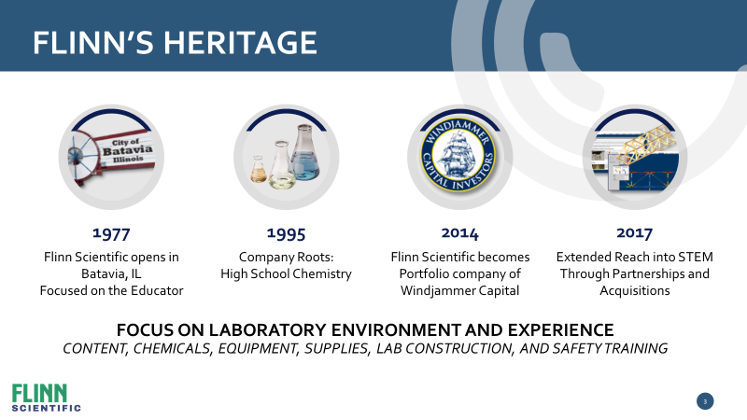
Flinn Scientific supports science educators in opening young minds to the challenges and joys of scientific discovery. We understand that science is a primary source of America’s unparalleled productivity, quality of life, and technological leadership. Through our unsurpassed customer service, we provide the science community with the very best education supplies, safety information, instructional materials, and programs to facilitate their vital work. Our respect for and loyalty to the science community is central to everything we do, and our relationship with them is always our priority.

Our Philosophy
To exceed customers’ expectations, our team provides the resources, tools, and training they need to be successful. Our goal is to make the customers’ role easier, safer, and more impactful through a “Customer First” experience. Our success is obtained primarily by how much we utilize our combined knowledge to anticipate and meet changing customer needs. We are committed to a culture and environment that is stimulating, challenging, and promotes individual growth. Leveraging our diverse talents to work together best enables us to develop and provide quality products and solutions that make a difference in the lives of students and educators. We achieve our goals through positive, supportive relationships and work environments based on truth and respect for the dignity of everyone. We believe creativity and innovation are critical in driving our ongoing success. Only with a financially strong and stable company that utilizes its resources effectively can we exceed the expectations of our customers, employees, and shareholders.

Our Core Values
Customer First | Understand and develop relationships with customers to anticipate and exceed their needs.
Value Creation | Achieve superior results by making more informed decisions through optimization, innovation, and expansion into new opportunities.
Respect | Treat others with honesty, dignity, respect, and sensitivity. Appreciate the value of diversity. Encourage and practice teamwork.
Knowledge Seek | Use and proactively share knowledge while embracing a constructive challenge process. Develop measures that lead to profitable action.
Change | Anticipate and embrace change. Envision what could be, challenge the status quo and empower teammates to engage in experimental discovery.
Development | Set high expectations for yourself and demonstrate the judgment, initiative, flexibility, teamwork, and critical-thinking skills necessary to make the greatest contribution to Flinn.
Humility | Exemplify humility and intellectual honesty. Constantly seek to understand and constructively deal with reality to create value and achieve personal improvement. Hold yourself and others accountable.
Integrity | Conduct all activities with integrity, for which courage is the foundation.
Fulfillment | Find satisfaction and meaning in your work by fully developing your capabilities to produce results that create the greatest value.

