(INSERT CUSTOMER)

(INSERT DESCRIPTION OF PROPOSAL)

Investment Summary

Submitted on (Day, Month XX, 2020)

Table of contents

Executive Summary 3
The Right Strategic Partner for (INSERT CUSTOMER) 4
Our Guarantee 5
Customer Vision Match 6
(INSERT CUSTOMER ACRONYM) Mission 6
(INSERT CUSTOMER ACRONYM) Vision 6
White Box Learning Executive Summary 7
The Problem with “Traditional” STEM Projects 8
The WhiteBox Learning Solution 10
The Student Experience 11
The Teacher Experience 12
Product Information 13
District Investment / Pricing Summary 15
Potential Funding Sources 16
Federal Funds 16
State and Local Funds 16
Company Overview 17
Appendix A: Company Heritage 18
Our Mission 20
Our Philosophy 20
Our Core Values 20
Appendix B: Flinn Scientific Solutions 22
WhiteBox Learning™ 22
FlinnSTEM® 22
360 Science® 23
FlinnPrep® 23
Chemventory™ 24
Chemventory™ & Science Safety Courses for Teachers™ 24
SciMatCo 25
U-Design™ – Science & STEM Labs – Online Planner 26
Science Essential Purchase Guide™ - Ordering made Easy 26
Appendix C: Investment Summary 27

Executive Summary

Flinn Scientific (Flinn) was created from a desire to serve science teachers has grown to become a trusted source for science supplies and equipment, laboratory chemicals, and lab safety resources. Our brand promise speaks for itself; Premium Quality, Exceptional Service, and Deep Scientific Expertise, Guaranteed!

A Trusted Name in Laboratory Supplies and Safety
Flinn Scientific supports science educators in opening young minds to the challenges and joys of scientific discovery. The leader in science lab supplies and safety, we provide learning systems and professional development that incorporate differentiated digital experiences with hands-on learning to bring out the inner scientist in every student. America’s science teachers rely on Flinn’s leadership, reputation, and commitment to bring the best of science education solutions for their students.

A Partner in Science and STEAM Education
Flinn Scientific creates programs and experiences that teach your students to think critically and evaluate information - building a passion for exploration and scientific inquiry. Additionally, programs:
- Are highly adaptable to suit students of various needs
- Incorporate inquiry-based principles
- Take an applied approach that’s grounded in the real-world, teaching skills in a way they will be used in the workforce and in real life
- Establish a strong education and laboratory infrastructure focused on safety
- Ensure science and STEAM is well integrated in your education system as a critical component for self-discovery

Response to Investment Request
(INSERT SPECIFIC RESPONSE TO THE RFP WHICH SUMMARIES THE PROBLEM, SOLUTION, & HIGH LEVEL INVESTMENT STATEMENT WITH ACTUAL RFP WITH AND / OR WITHOUT PRICING ON Appendix C beginning on page XX.

The Right Strategic Partner for (INSERT CUSTOMER)

Flinn is Customer Centric and Responsive, with a Mission for Hands-On Science Education.
- Strong brand equity and a legacy of understanding and fulfilling teachers needs
- Net Promoter Score (79) results from responsiveness and attention to detail to both vendors’ and customers’ needs
- Past, present and future product roadmaps emphasize the importance of experiencing science in the classroom
- Flinn’s promise is: Premium Quality, Exceptional Service, and Deep Scientific Expertise, Guaranteed!

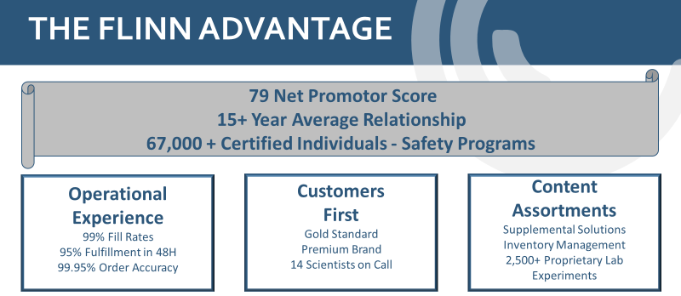

Our Guarantee

Flinn Scientific, Inc. guarantees that no sale is complete unless the customer is satisfied and properly trained to deliver science solutions in a safe and rewarding education environment. We also guarantee that every item we furnish will either conform to the catalog specification, or we will ask your permission, prior to shipment, to ship an alternative product. Flinn has tested all the equipment we sell and will never allow our customers the opportunity to invest in a product we have deemed inferior to an item being ordered. Flinn honors all third-party warranties and will further provide additional years for customers who are part of our concierge program including replacement cost program for accidents which may occur from time to time.

Customer Testimonials

You have a fantastic selection! I order for my entire building and I always have found that you carry what I need - everything - which makes my job much easier! Thank you!
Amy McMillan
Wilson Middle School
Lorain, OH
Your company provides the highest quality service and products - Thanks! I enjoy the extras you provide like the labs, demos, Web site, safety information, etc. Great Job!
Rus Steinbach
Jefferson High School
Portland, OR
I am very pleased to order from Flinn. No other company cares as much about safety. Your catalog is a huge asset. Your service is prompt, accurate, and you have great prices.
Jodi Warner
Greenway High School
Coleraine, MN
Your company is by far #1! Your staff is outstanding, and service is exceptional. Thank you for making my job as a teacher easier and more fun!
Olivia Parker
Coulterville Unit School
Coulterville, IL

Customer Vision Match

(INSERT CUSTOMER ACRONYM) Mission
(INSERT CUSTOMER MISSION)

(INSERT FLINN RESPONSE TO CUSTOMERS MISSION) Flinn Scientific goes beyond the laboratory supplies and equipment to provide inquiry lab solutions to invigorate the minds of our students through real world storylines that are impacting change every day. The experiences encourage exploration into the aligned career cluster associated with science, technology, engineering, and math. A listing of these solutions can be found in Appendix A.

(INSERT CUSTOMER ACRONYM) Vision
(INSERT CUSTOMER VISION)

(INSERT FLINN RESPONSE TO CUSTOMERS VISION) Flinn Scientific offering support for advanced academics in the sciences; biology, chemistry, physics, and environmental science combined with addressing the multi-modality of learners through a series of educational videos, virtual reality, research based journals, hands-on inquiry labs, and professional development to train educators how to incorporate STEAM based education alignment into the core subject areas. This alignment along with the real-world storylines and reference of career pathways support the development of learning beyond the classroom, tied to various professions along with the opportunity to experience the design thinking process while allowing the learners to accept failure and learn from their exploration of discovery. A listing of these solutions can be found in Appendix B.

White Box Learning Executive Summary

An effective engineering curriculum provides great potential for middle and high school STEM teaching and learning. This is because an authentic engineering practice embodies the practical application of science, technology and math to solve a meaningful problem. Engineering is STEM, and if delivered effectively, students will find meaning in complementary disciplines and ultimately acquire the confidence and motivation to pursue a career in STEM. But there’s a problem. A truly authentic engineering practice is inherently iterative - highly iterative – and teachers and students simply don’t have the time or money for the level of iteration that yields deep and meaningful levels of learning.
WhiteBox Learning provides a unique and extraordinarily effective solution to this problem. Using our system, students design, analyze, test, and build popular educational products like CO₂ powered cars, balsa wood bridges, balsa wood gliders, water bottle rockets, mousetrap cars, wind turbines, solar panels, and more. While these products have all been in use for many years in science and technology education, WhiteBox Learning elevates the educational value of each by immersing students into an extraordinarily engaging and authentic engineering design process.

Using our system, students log into a web-based application complete with built-in science and math content, custom computer-aided design (CAD), and custom computer-aided engineering (CAE) tools to design and analyze a virtual model – all on the web. When a student has completed a design, they can enter it into a robust online competition in which they are challenged by other students in their class, district, state, nation, or world. This challenge, and the satisfaction of climbing a leader board is so compelling that, on average, students complete sixty-two (62) virtual design iterations before building a physical model of their optimized design. The authenticity of the process, particularly the existence of such highly informed design iterations, yields deep and meaningful levels of STEM learning.

The system also includes a Teacher Control Center (TCC). The TCC is effectively a learning management system that provides the ability to set up classes, assign activities, distribute login IDs, and even change the specifications (competition rules) for an activity. The TCC also provides the ability to monitor the student’s use of the application. Detailed graphs, tables, and other charts illustrate overall class or individual progress and performance. In short, the TCC monitoring tools provide teachers with the intelligence to know when and where to intervene to ensure that students get help when needed.

The Problem with “Traditional” STEM Projects

An effective engineering curriculum provides great potential for middle and high school STEM teaching and learning. This is because an authentic engineering practice embodies the practical application of science, technology and math to solve a meaningful problem. But there’s a problem. A truly authentic engineering practice is inherently iterative - highly iterative – and teachers and students simply don’t
have the time or money for the level of iteration that yields deep and meaningful levels of learning.

The balsa wood bridge project provides a classic example of the problem. For decades, teachers have used the project to teach students about the strength of a truss. The potential of this and so many other great science and engineering projects is that it provides for students to apply what they’ve learned in science, math, and technology education to solve an authentic problem.

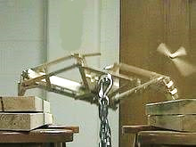
The project begins with a discussion about key science and math concepts related to truss design. To apply this knowledge as intended, students should sketch a design and then establish the capacity of the bridge by calculating the internal forces in each web member, determining whether the web member is in compression or tension, and then comparing the internal force to the relevant yield strength. For the truss in the image above, this would require 29 discreet, multi-step calculations. Furthermore, any small change in the design requires that all 29 calculations be performed again. The complexity of the problem, and shear number of calculations required for a thorough analysis essentially means that the science and math concepts that govern the performance of the design are left in the abstract. There just isn’t enough time.
Bridge Test

For practical reasons, students simply sketch a design that seems logical, and then go about building a physical model of the design. Lastly, to establish the capacity of the bridge, the model is tested by gradually increasing a load until it is destroyed. Sadly, the lesson is over because there isn’t enough time or money to work through the entire process again. Furthermore, even if there were more time and money, testing the bridge in this manner provides very little insight (if any) on why the bridge failed as it did and what could be done to make it better.
Teachers and students have worked with balsa wood bridges for decades. It is a fun and useful activity, but it is not an authentic engineering activity.

This same narrative applies to many other traditional science and technology education projects. The good news is that there is a better way that doesn’t require that we throw the baby out with the bathwater. There is a way to work through these great, and familiar projects that yields an exceedingly authentic engineering experience.

The WhiteBox Learning Solution

WhiteBox Learning provides a unique and extraordinarily effective solution to this problem. Using our system, students design, analyze, test, and build popular educational products like CO₂ powered cars, balsa wood bridges, balsa wood gliders, water bottle rockets, mousetrap cars, wind turbines, solar panels, and more. While these products have all been in use for many years in science and technology education, WhiteBox Learning elevates the educational value of each by immersing students into an extraordinarily engaging and authentic engineering design process.

The system is entirely web-based, and all projects are aligned with Next Generation Science Standards (NGSS), Standards for Technological Literacy (STL) and others. What follows is a brief description of the student and teacher experiences.

The Student Experience
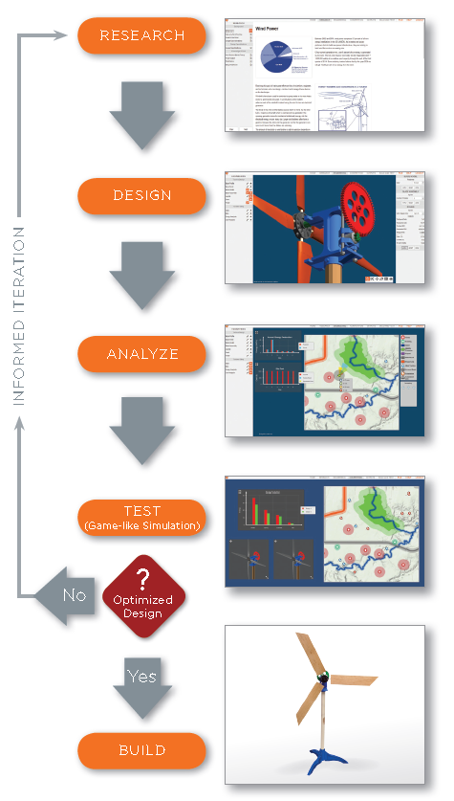
Students log into a single web-based application and find all relevant and age appropriate science and math content including reading materials and quizzes, custom computer-aided design (CAD), and custom computer-aided engineering (CAE) tools to design and analyze a 3D virtual model. They can then enter their design into an online simulation in which they test their virtual design in the context of an engaging online competition with their classmates, other students in the district, state, nation, or world. At the end of a single iteration (competition) students are provided with detailed diagnostics about their design as well as that of their competitor. This enables each student to develop their own theory about how to improve the design and then return to other parts of the application to act on that theory.
Wind Turbine Virtual and Physical Models

The process yields a cycle of informed iteration, in which the student learns more and more about the science and math that governs the performance of their design with each iteration. Iteration is an essential part of the engineering design process and WhiteBox Learning provides for such an engaging experience that students average 62 virtual design iterations (without being asked). Their quest to climb the leader board compels them to immerse themselves into an extraordinarily comprehensive engineering design process.

When the virtual modeling process is complete, students can output reports, print templates or drawings, or (when applicable) other files to drive a 3D printer, laser cutter, or CNC (computer numerical control) to automatically manufacture parts of their design. While we certainly encourage teachers to engage their students in the complete “art-to-part” process, many teachers – due to time or budget constraints – choose to only use the virtual part of the system for some projects.

The Teacher Experience
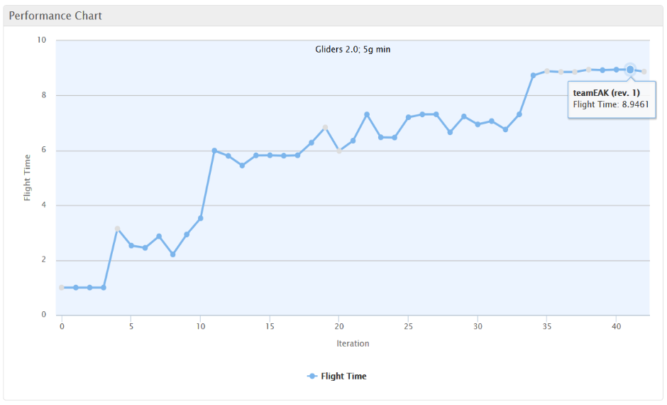
The system also includes a Teacher Control Center (TCC). The TCC is effectively a learning management system that provides the ability to set up classes, assign activities, distribute login IDs, and even change the specifications (competition rules) for an activity. The TCC also provides the ability to monitor the student’s use of the application. Detailed graphs, tables, and other charts illustrate overall class or individual progress and performance.
Individual Student Performance (Glider Flight Time, 42 iterations)

The monitoring tools provide teachers with information to know when and where to intervene. Clearly, the student in the adjacent chart is doing well and can be left to her own. Other charts illustrate students struggling and in need of help. Overall, the system engages students (this student designed 42 gliders!) and provides for them to move at their own pace. It also provides teachers with the intelligence to focus their energy where it is needed.

Product Information

The following tables provides a brief description of each of the eleven projects currently available. Additional details are available online at https://www.whiteboxlearning.com/applications.
In general, we recommend approximately fifteen hours of class per project – ten hours using the online application, and five hours building and testing physical models. Applied across eleven projects, the curriculum totals approximately 165 hours of curriculum. The curriculum is quite flexible, however. Teachers can forego the physical modeling process to save time and money and can easily take more or less time working within the virtual system.
Project | Science and Math Focus | Engineering Technologies
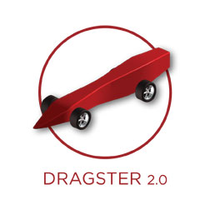 | Newtonian Physics: Newton’s Laws, Mass, Surface Friction, Drag, Acceleration | CAD, CAE, Graphs and Charts, CNC, Print Templates, Drawings, 3D printing
 | Statics: Method of Joints, Stability, Compression, Tension, Yield Strength | CAD, CAE, Graphs and Charts, Print Templates
 | Renewable Energy: Electronics, Earth Sciences, Solar, Rechargeable Batteries | CAD, CAE, Graphs and Charts, Print Templates, 3D Printing
 | Aeronautics: Forces of Flight, Stability, Newton’s Laws | CAD, CAE, Graphs and Charts, Print Templates, Laser Cutting
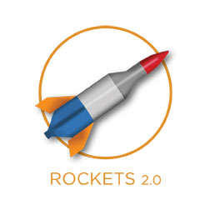 | Rocketry and Ballistics: Forces of Flight Stability, Recovery, Newton’s Laws | CAD, CAE, Graphs and Charts, Print Templates, Laser Cutting, 3D Printing
 | Simple Machines: Levers, Wheel and Axle, Power, Energy, Newton’s Laws | CAD, CAE, Graphs and Charts, Drawings, 3D Printing

Project | Science and Math Focus | Engineering Technologies
 | Bio-Physics: Biomimicry, Projectile Motion, Conservation of Energy | CAD, CAE, Graphs and Charts, Drawings
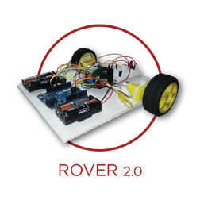 | Robotics and Programming: Electronic Circuits, Robotics, Computer Programming, Mechatronics | CAE, Graphs and Charts, 3D Printing, Arduino Output
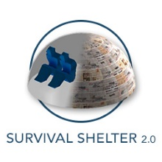 | Heat Flow: Human Energy, Resource Allocation, Conductive Heat Flow | CAD, Graphs and Charts
 | Wind Energy: Environmental Science, Turbine Blade Design, Wind Farm Siting | CAD, CAE, Graphs and Charts, Print Template, Laser Cutting, 3D Printing
 | Chemistry: Photovoltaics, Alternative Energy | CAD, CAE, Graphs and Charts

District Investment / Pricing Summary

The following pricing includes full access to all applications for an unlimited number of students at each school.

Potential Funding Sources

Funding for WhiteBox Learning products and services typically comes from a variety of federal, state, and local sources. The following is a list of federal sources that may be helpful.

Federal Funds
There are many sources of federal funds available to schools for the purchase of STEM.
- Title I – Career and College Readiness
- Title I, Section 1003g – School Improvement Grants
- Title IV – 21st Century Community Learning Centers
- Title V – Gifted Programs
- IDEA – Special Education
- Charter School Programs
- Carl D. Perkins Act (Career and Technology Education only)

State and Local Funds
Provide custom sources (based on location of district).

Company Overview

Official Registered Name: Flinn Scientific
Dun & Bradstreet Number: 08-521-7701
Address: 770 North Raddant Road, Batavia, IL 60510
Toll-Free Number: 800-452-1261
Fax Number: 866-452-1436
Key Contacts:

Thomas Trapp Chris Daily

Sr. Account Executive
770 North Raddant Road
Batavia, IL 60510
ttrapp@flinnsci.com
402-960-5578 (Cell)
866-452-1436 (fax)

Account Executive
770 North Raddant Road
Batavia, IL 60510
cdaily@flinnsci.com
630-389-5005 (direct line)
866-452-1436 (fax)

Person Authorized to Contractually Bind Organization:

Both of the following individuals are authorized to bind Flinn Scientific for any contract award resulting from this RFP:

Daniel C. Cavalli
Chief Sales Officer
770 North Raddant Road
Batavia, IL 60510
732-759-7607
dcavalli@flinnsci.com

Kevin Theesfeld
Director of Sales
770 North Raddant Road
Batavia, IL 60510
800-452-1261 x 3733
ktheesfeld@flinnsci.com

Appendix A: Company Heritage

It was 1977 when Lawrence Flinn Jr. proposed an idea to his family―a risky idea that could jeopardize their security and his career. After working for two large laboratory supply companies and being stonewalled in his attempts to convince them to provide better service and products for teachers, Lawrence’s passion for science education led to a courageous decision to quit his executive job and start a new company.

As Lawrence’s oldest son, Larry Flinn III, remembers, “On the day I graduated from college, my dad said, ‘Larry, how would you like to start our own business?’ He had the vision to start a business that only focused on science teachers and their needs. He put everything he owned at risk, including his home and his pension. We borrowed money and went to work!”

With only three employees―Lawrence, his wife Margaret, and Larry―Flinn Scientific began in the basement of their home in Batavia, Illinois, with a few worktables made from old doors laid on top of used file cabinets. To pay the bills, father and son worked night jobs at local factories, though admittedly, they would sometimes “call in sick” so they could travel to schools and teacher conventions and to conduct workshops. Larry’s brother Patrick joined the company as soon as the business could support another partner.

Teachers recognized that Flinn Scientific was indeed different from other companies. Here was a family-owned business that truly put the needs of its customers first! The most critical need of all was laboratory safety. Flinn Scientific responded by providing safely packaged chemicals, free safety training, and unique safety products. A teacher in Texas described Flinn’s leadership in promoting safety by writing, “Flinn alone has done more for safety in the science classrooms of America than legislators and educators combined.”

With teachers as its top priority, Flinn Scientific introduced significant “firsts” including:
- Small, clearly labeled containers of chemicals to reduce the dangers of storage and spills
- Concise Safety Data Sheets formatted for teachers
- Chemical storage cabinets made of wood to withstand corrosion and fire
- A system of safe chemical storage based on chemical compatibility
- Chemical and biological disposal procedures for schools
- Safety workshops, training, and online certification courses for teachers
- The Flinn Scientific Catalog/Reference Manual filled with helpful tips and ideas
- A wealth of free resources available at flinnsci.com

The list of innovations continues to grow―and teacher associations from across the country have honored Flinn for its achievements. Teachers’ high regard for the company was expressed by William Hunter, Professor of Education at Illinois State University, who said, “Flinn Scientific had a reputation for being the most teacher-friendly supply company. Teachers trust them. Teachers rely on them.”

Teachers’ support of Flinn Scientific is reflected by the company’s impressive growth. It’s amazing to see the impact that Flinn Scientific’s success has had on the entire science supply business. The industry that once ignored Lawrence Flinn’s ideas now looks at Flinn Scientific as a role model. With great pride, Flinn Scientific continues the tradition of putting its customers first by providing quality products, outstanding service, fast delivery, and safety leadership.

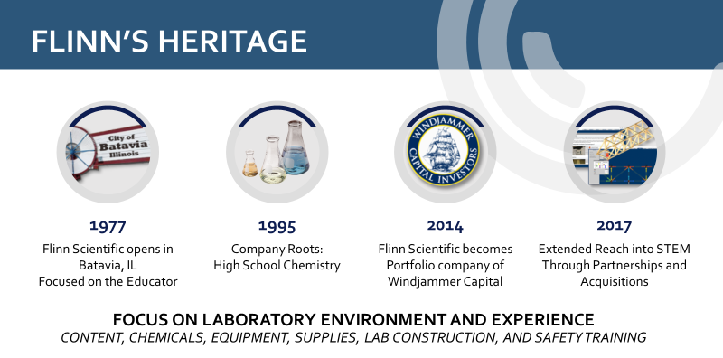

Our Mission
Flinn Scientific supports science educators in opening young minds to the challenges and joys of scientific discovery. We understand that science is a primary source of America’s unparalleled productivity, quality of life, and technological leadership. Through our unsurpassed customer service, we provide the science community with the very best education supplies, safety information, instructional materials and programs to facilitate their vital work. Our respect for and loyalty to the science community is central to everything we do, and our relationship with them is always our priority.

Our Philosophy
To exceed customers’ expectations, our team provides the resources, tools, and training they need to be successful. Our goal is to make the customers’ role easier, safer, and more impactful through a “Customer First” experience. Our success is obtained primarily by how much we utilize our combined knowledge to anticipate and meet changing customer needs. We are committed to a culture and environment that is stimulating, challenging, and promotes individual growth. Leveraging our diverse talents to work together best enables us to develop and provide quality products and solutions that make a difference in the lives of students and educators. We achieve our goals through positive, supportive relationships and work environments based on truth and respect for the dignity of everyone.
We believe creativity and innovation are critical in driving our ongoing success. Only with a financially strong and stable company that utilizes its resources effectively can we exceed the expectations of our customers, employees, and shareholders.

Our Core Values
Customer First
Understand and develop relationships with customers to anticipate and exceed their needs.
Value Creation
Create long-term value for the customer, the company, and its shareholders through economic means. Achieve superior results by making more informed decisions through optimization, innovation, and expansion into new opportunities.
Respect
Treat others with honesty, dignity, respect, and sensitivity. Appreciate the value of diversity. Encourage and practice teamwork.

Knowledge Seek
Use and proactively share knowledge while embracing a constructive challenge process. Develop measures that lead to profitable action.
Change
Anticipate and embrace change. Envision what could be, challenge the status quo and empower teammates to engage in experimental discovery.
Development
Set high expectations for yourself and demonstrate the judgment, initiative, flexibility, teamwork, and critical-thinking skills necessary to make the greatest contribution to Flinn.
Humility
Exemplify humility and intellectual honesty. Constantly seek to understand and constructively deal with reality to create value and achieve personal improvement. Hold yourself and others accountable.
Integrity
Conduct all activities with integrity, for which courage is the foundation.
Fulfillment
Find satisfaction and meaning in your work by fully developing your capabilities to produce results that create the greatest value.

Appendix B: Flinn Scientific Solutions

WhiteBox Learning™
WhiteBox Learning is a web-based STEM learning system for grades 6-12 that brings real-world design to the classroom. Using the system’s 12 Next Generation Science Standards-aligned applications, students can design an analyze a 3-D model, learn through simulations, and conduct countless design iterations before building the physical model to complete the learning experience. Students can access, analyze, and save their designs anytime, anywhere. The system also allows students to collaborate with their peers on designs and offers opportunities to participate in design competitions with fellow students in their school, district, and state, as well as across the country and world. WhiteBox Learning addresses various learning styles and provides all students with an engaging way to gain exposure to engineering design and the STEM career cluster for Career and Technical Education.
WhiteBox Learning ‘s unique ability to allow for unlimited design iterations is a critical process in giving students a real-world experience. www.whiteboxlearning.com

FlinnSTEM®
FlinnSTEM is a standards-aligned STEM curriculum for grades 4-8 that uses an engaging hands-on approach to guide students to explore new science concepts, connect to real-world experiences, and discover engineering design and scientific inquiry. Robust professional development is embedded in the program, giving educators everything, they need to teach STEM. FlinnSTEM professional development provides teachers with great digital content, including background information, suggested inquiry approaches, point-of-use, professional development videos, writable student activities and debrief questions.

FlinnSTEM is adaptable to fit any learning environment. In the regular classroom, the program can be embedded in daily instruction and existing curriculum. FlinnSTEM is also perfect for outside the classroom, like after-school programs and STEM-focused clubs. The units also provide content
knowledge and hands-on experiences for student-driven projects in makerspace. www.flinnstem.com

360 Science®
360 science was born out of our partnership with Pearson in the formation of their high school chemistry curriculum. Their instructional approach is unique in that it begins each day with an inquiry lab supporting that with written research in a traditional textbook format. This approach intensifies the need for hands -on learning in the classroom and supports NGSS and associated science state standards. 360 science goes beyond the curriculum instruction to include a robust teacher management system that allows the instructor to customize the lessons based on students’ skill set and level in the high school classroom, for example, college prep, honors, dual enrollment, and Advanced Placement courses. 360 Science’s differentiated (or leveled) learning allows instructors to teach the same hands-on activity to students of different skill sets. The virtual reality component allows students to engage deeper in the activities and get a truer understanding of science at the molecular level. Flinn’s legacy is to think about the teachers’ needs and safety first and foremost, so all labs come with both print and digital instructions and safety guidelines and that all-important teacher dashboard for classroom management and rostering. This learning solution is available today in individual lab format, as a unique story line experience solution, and as a district-wide offering with flexible pricing options. https://www.flinnsci.com/learning-solutions/360Science/

FlinnPrep®
FlinnPrep is a complete learning solution that helps prepare and support students as they interact with the fast pace and rigor of Advanced Placement science courses. With online courses and inquiry labs, it is built to cover the full AP Curriculum, from the hands-on to the conceptual, all the way to the exam. FlinnPrep’s courses and inquiry labs are aligned with the College Board’s Big Ideas, Learning Objectives and Science Practice for AP Curriculum, ensuring content that supports raising students’ AP test scores and preparing them for higher learning. Full-length practice exams are included to replicate the real AP exam experience. Covering AP Biology, AP Chemistry, AP Environmental Sciences, and AP Physics, each online course features easy-to-understand content, videos and animations that bring the content to life, competitive games to support review, formative and summative assessments with just-in-time feedback, and full-length practice exams. With FlinnPrep, students have year-round course access to review, practice, and prepare for AP® exams on their own time and at their own pace. FlinnPrep’s inquiry labs help teachers and students unpack the lab concepts, so that everything done in the lab relates right back to the exam. Online resources include introductory and technique videos, a summary video describing how lab experiences can appear on the exam and AP-style questions students can use to prep for the exam. FlinnPrep can be used as a primary or supplementary content source. Its flexible design and teacher center make it easy to personalize learning for students. Each lab includes two implementation paths, a low guided procedure to challenge advanced students with inquiry-based science and a high-guided procedure for students who need more direction, making the program applicable for students in dual-enrollment courses. www.flinnprep.com

Chemventory™
Flinn’s Online Chemventory™ is a secure cloud-based service that can be accessed by any computer or tablet with an internet connection, allowing convenient access to your Chemventory™ database from your chemical storeroom and classroom. With Chemventory you’ll have peace of mind knowing that your data is stored on a secure server remotely and can be easily accessed 24/7. Plus, it’s simple to add Flinn chemicals to your Flinn Online Chemventory database by just looking up chemicals by keyword, catalog number, or alphabetical index and selecting what you have in stock to add to your database. Do you share a storeroom with other teachers in your department? With Flinn Online Chemventory™ you can setup one database and invite other teachers, lab managers, and/or administrators to view or update your Chemventory™ database for no additional charge. Flinn Online Chemventory™ gives you the flexibility to classify each chemical in your inventory by the school name, chemical storeroom location, and shelf/cabinet location. You can then sort your list by each of these categories. If your school has multiple chemical storeroom locations, or your school district has multiple school locations it will be more manageable to keep chemical inventory files in more than one Chemventory™ database. Flinn has made it easy to set-up multiple databases and link access to users. We have included new GHS pictograms and hazard information with every Flinn chemical in our Online Chemventory™ program. GHS pictograms and hazard statements can also be printed on chemical labels through the Online Chemventory™ program. https://chemventory.flinnsci.com/

Chemventory™ & Science Safety Courses for Teachers™
Conducting science lab activities safely and managing chemicals and hazardous materials in your schools requires the right tools for inventory and safety training. Flinn offers both in our exclusive Science Safety Courses™ for teachers and Chemventory™ to assist with the management of Professional Development and Regulatory Compliance for your science teachers and schools. Education is our best preventative measure to reduce the risk of accidents in the classroom and laboratory. Optimized science safety at Flinn includes our exclusive 7-Star Science Safety Solution consisting of: 1.) Science Safety Teacher Training & Certification – on-site, on-line, or on-demand, 2.) Science Room Safety Self-Inspections, 3.) Chemventory™ for Responsible Chemical Management, 4.) Student Safety Contracts, 5.) Departmental Safety Notes & Calendar, 6.) Annual Science Safety Reviews, and 7.) Science Safety First Inventory & Science Essentials Purchase Guide. This solution is unparalleled for districts seeking the premier science safety solution in education.
SciMatCo
SciMatCo, A Flinn Scientific Company, manufactures and distributes non-metallic safety storage cabinets and related products. Founded in 1989 and based in Batavia, Illinois, SciMatCo offers a wide variety of high-quality options in various sizes and configurations for the safest storage of all types of hazardous materials. All SciMatCo products are proudly made in the USA and are distributed worldwide. What is a Safety Storage Cabinet? A cabinet built specifically for the safe storage of hazardous chemicals or substances. Safety storage cabinets must be built using the correct materials and construction methods to safely isolate or protect volatile contents from each other or from the effects of environmental hazards. Properly built safety storage cabinets:
- Protect people, facilities and their contents from potentially unsafe conditions.
- Should be code compliant and certified for safety.
Why Choose SciMatCo Storage Cabinets?
- Safety – Our wood and plastic cabinets do not react with acid or corrosives as metal cabinets do. – Wood cabinets are the safest choices for flammables since wood is a thermal insulator.
- Long life – Wood or plastic cabinets last many years since they never rust or corrode. – Rugged 1” exterior plywood construction withstands the most abusive environments.
- Code and standards compliant – Meet and exceed OSHA, NFPA, IFC and UFC standards – UL listed (flammables) • Different sizes and configurations – Benchtop and Under-the counter (UTC) cabinets – Stand-alone floor cabinets – Space saving stacking cabinets – Combination Cabinets – Mobile Cabinets – Solid Polypropylene Cabinets – Custom Made Cabinets
- Extensive product line – Flammables cabinets – Cabinets for Acids and bases – Corrosive cabinets – General purpose cabinets
A wooden flammables cabinet?
- Yes. It’s not only possible, but better! Protects from Flames Structural Integrity Heat Insulation
- SciMatCo Flammables cabinets are UL-listed and meet all OSHA, NFPA, IFC and UFC standards.
- Metal is a heat conductor whereas wood is a thermal insulator; metal cabinets become ovens while wooden cabinets protect against the heat.
- Wooden cabinets do not distort or bend the way metal cabinets do when exposed to flame.
For more information please visit: https://scimatco.com/

U-Design™ – Science & STEM Labs – Online Planner
Optimizing New and Renovated science or STEM rooms requires careful planning and preparation. Flinn’s experience and advice when planning these areas is a wise counsel to avoid the potential pitfalls that often plague science rooms for decades. Throughout the planning process, Flinn offers advice at each stage for appropriate space-planning, configurations, 21st Century learning recommendation, digital solutions, fixtures, furniture & Equipment (FF&E), optimized outfitting with supplies, and the services that take away the stress of opening new spaces.
U-Design™ is Flinn’s exclusive Science & STEM Room space planner that is an interactive tool to be used to plan complete labs from an empty room with the fixtures, furniture, equipment, safety and supplies. This free online tool prepares educators to have a voice in the planning process and may be used to completely design the ideal STEM or Science room. Completed designs produce an interactive counsel with our planning team, a 2-D rendering, and a budgetary estimate for the space.

Science Essential Purchase Guide™ - Ordering made Easy
Ordering annually and outfitting science is optimized when using Flinn’s exclusive Science Essentials Purchase Guide™ as a handy tool. Featuring Teachers’ Choice products that are Flinn’s best-selling products, teachers are directed to those essentials needed when ordering. Used as a companion ordering tool, the guide is organized with science safety first, followed by common labware and then discipline-specific products. This sequencing follows logically as prompts for the science essentials. The Purchase Guide is available in print, pdf and Excel versions for standardized ordering and communications, districtwide.

Appendix C: Investment Summary

